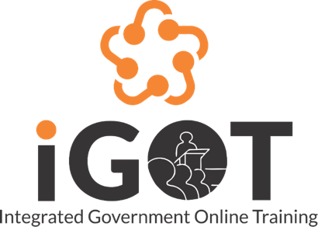

CBP PORTAL - USER MANUAL

User Manual

Document Version: 1.0

**Table of Contents**

Overview **3**

1.2 Link 3

1.3 Login 3

CBP Portal **4**

2.1.1 Upload file 9

2.1.2 Attach a link 12

2.1.3 Adding an assessment 13

2.1.4 Content settings 18

2.1.5 Content quality 20

2.1.6 Self curation 22

2.1.7 Summary 24

2.2 Review & Publishing 25

2.3 Editing & Unpublishing 29

2.4 My CBPs 31

2.5 All CBPs 31

2.6 Competencies 32

# **Overview**

The document describes how capacity building product providers or CBP providers can create a course, edit a course, review & publish the course. Also how they can request for new competencies.

## **1.2 Link**

Karmayogi user portal link stage: [https://.igot-stage.in/](https://igot-stage.in/)

CBP portal link stage : <https://cbp.igot-stage.in/>

## **1.3 Login**

Once the iGOT user account gets created, they receive an email to reset password.l

Users use the above karmayogi link to login to the Karmayogi portal.

After login to Karmayogi portal click on username on top right. Users can find portal links based on the roles of which user got created in the platform. From there users will be able to access the SPV portal, MDO portal, CBP and FRAC dictionary.

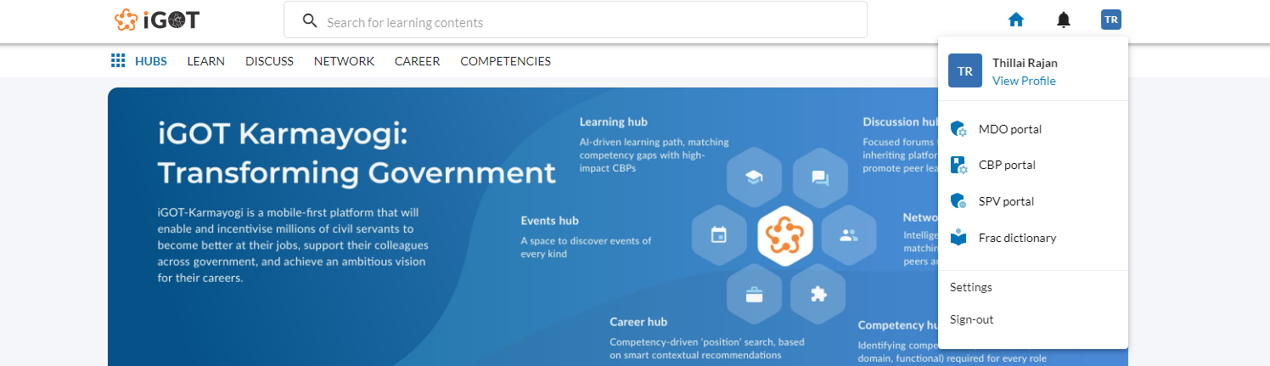

# **CBP Portal**

CBP portal is to create content,review and publish them into iGOT Karmayogi portal.

As the user clicks on the “CBP portal” link from the profile drop down of the Karmayogi portal, they will be navigated to the MDO portal. User roles like Editor, Content creator, Reviewer and Publisher have access to the CBP portal.

Created users in the MDO portal with roles of an Editor, Content creator, Reviewer and Publisher can access the CBP portal.

As the content creator logs in to the CBP portal, there will be four tabs in the home screen as :

1. Live: courses which are created by the content creator of the MDO.
2. Under review: courses which are sent for review.
3. Drafts: courses which are in progress and have not been completed
4. Inactive: Courses which are no longer valid.

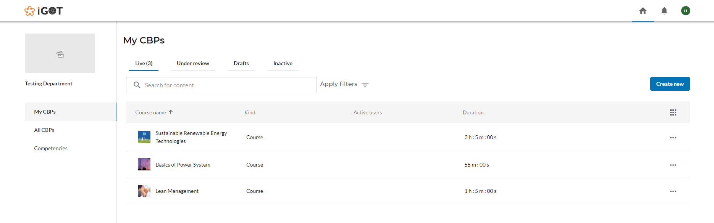

**2.1 Creating a course**

Content creator clicks on the “Create new” button on the top right to start creating a new course and lands on the below screen.

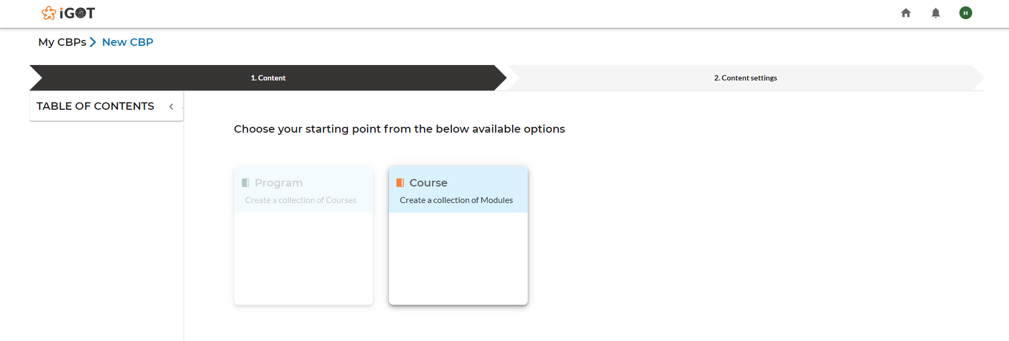

Content creator clicks on the “Course” option and lands on the below screen, where the content creator will enter the name of course that is being created.

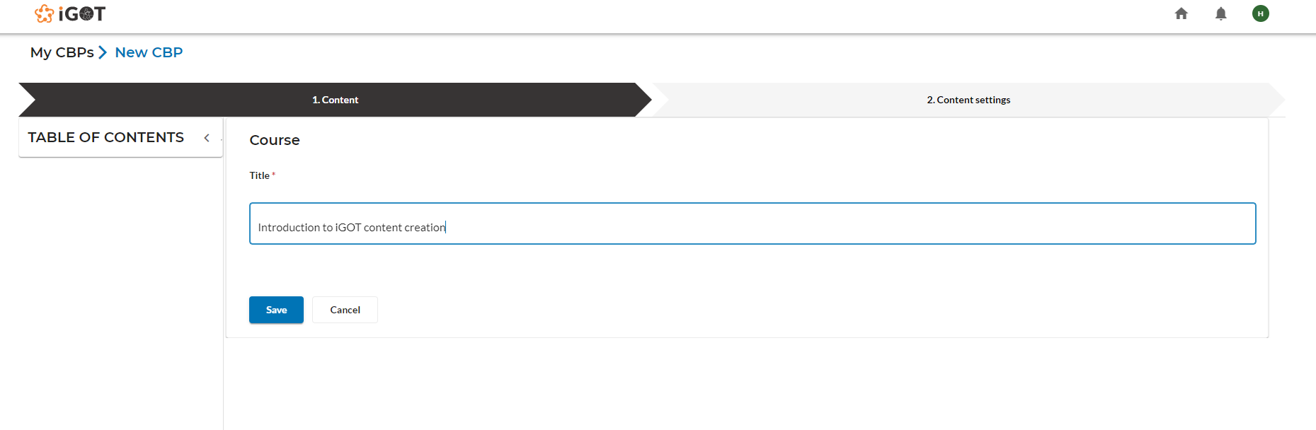

Note:

Hierarchy of course creation is as follows:

Course-> Module-> Resources or Course -> Resources

Content creator clicks on the “Save” button and lands on the content menu to add child content for the course.

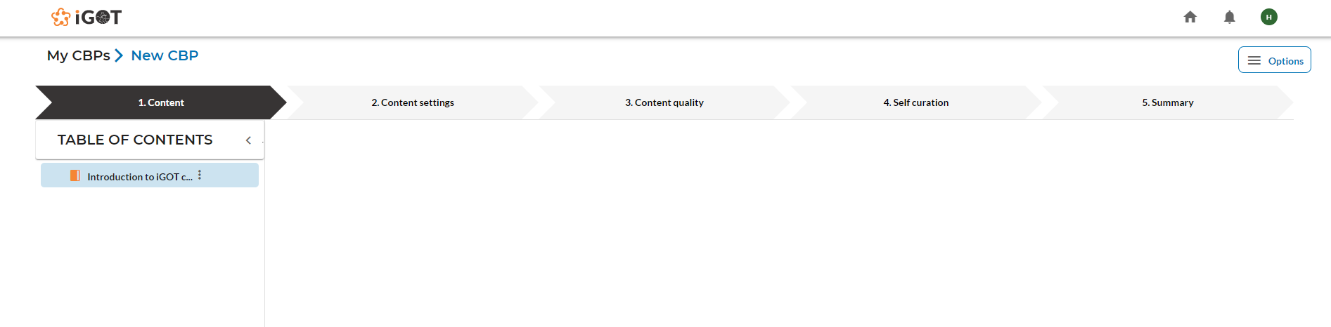

Content creator clicks on ‘three dots’ next to the course name and selects the “Create new child” option to create a module or resources for the course.

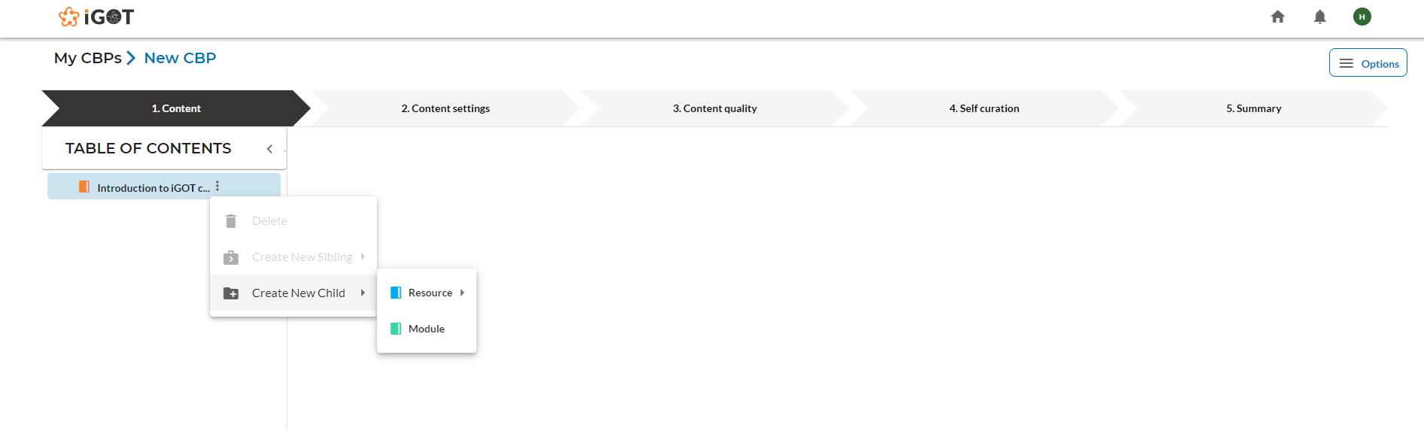

As the content creator selects resources, there will be three options as shown below.

1. Upload file: Upload file accepts MP4, MP3, PDF, ZIP (HTML content for this need to select index.html file as entry file)
2. Attach link: Embedded video links can be used here( Example : youTube embedded video link)
3. Assessment: Assessment accepts multiple choice questions(MCQ), ‘Fill in the blanks’ and ‘Match the following’.

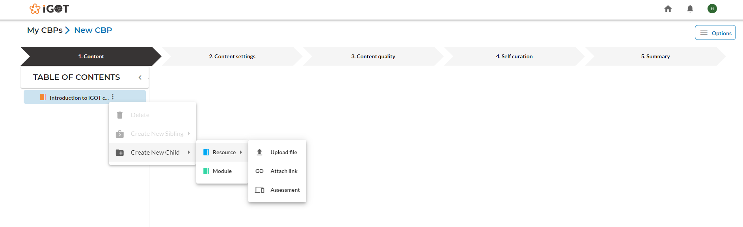

Content creator clicks on the “Module” option and lands on the below screen, where the user will enter the name of the module that is to be created under the course.

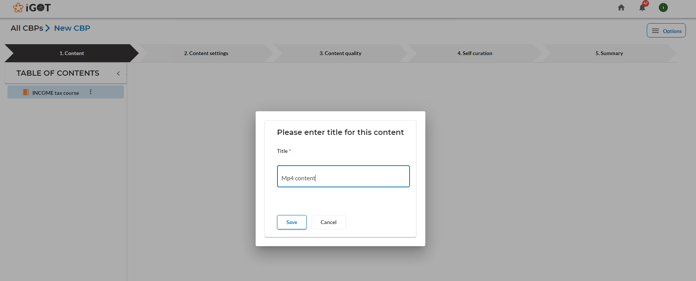

Content creator clicks on the “save” button and lands on the below screen

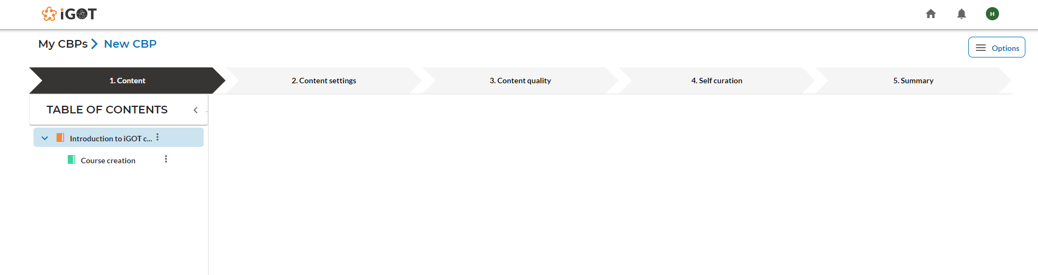

As the content creator clicks on three dots next to the module name, user will see the below options

1. Delete: User can click on “Delete” button to delete the created module
2. Create new sibling: User can create new resources under the course
3. Create new child: User can create new resource under the module

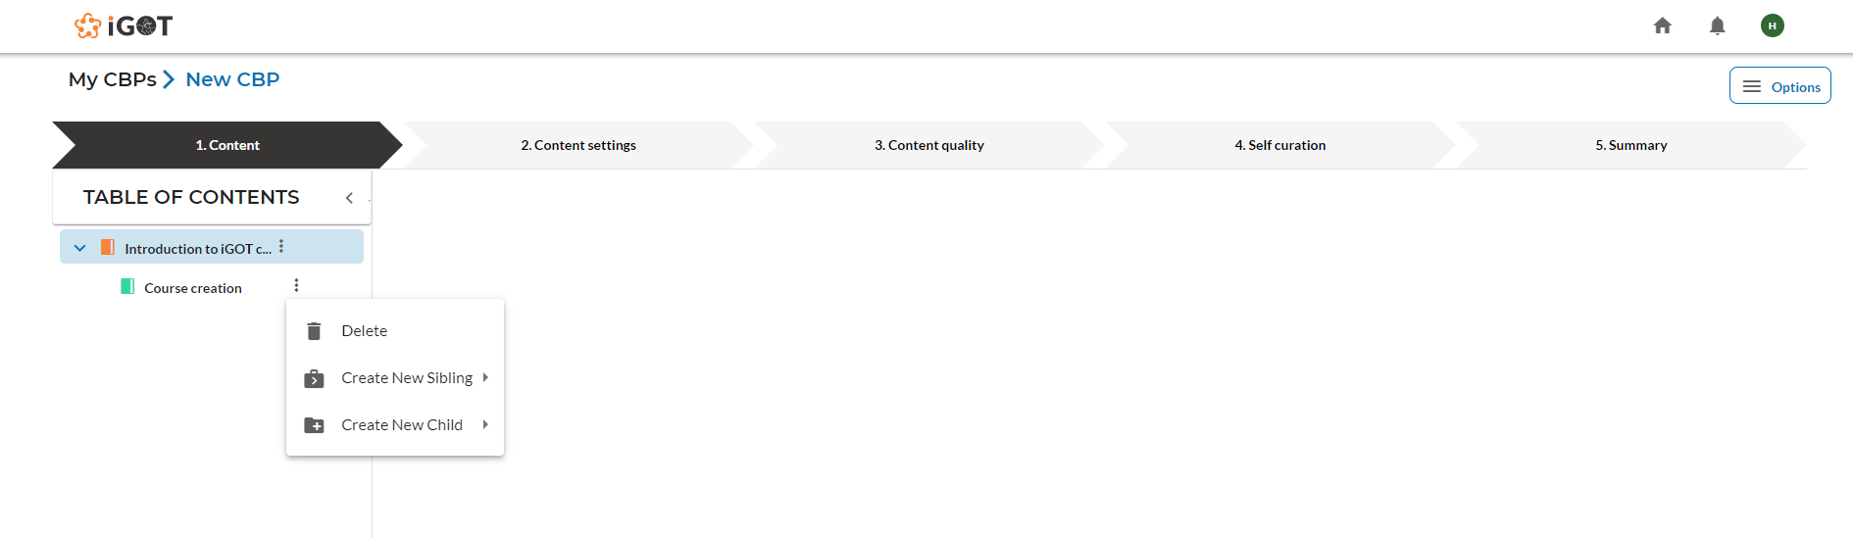

As the user Content creator on “Create new child” button , there will three options to add resources as shown below

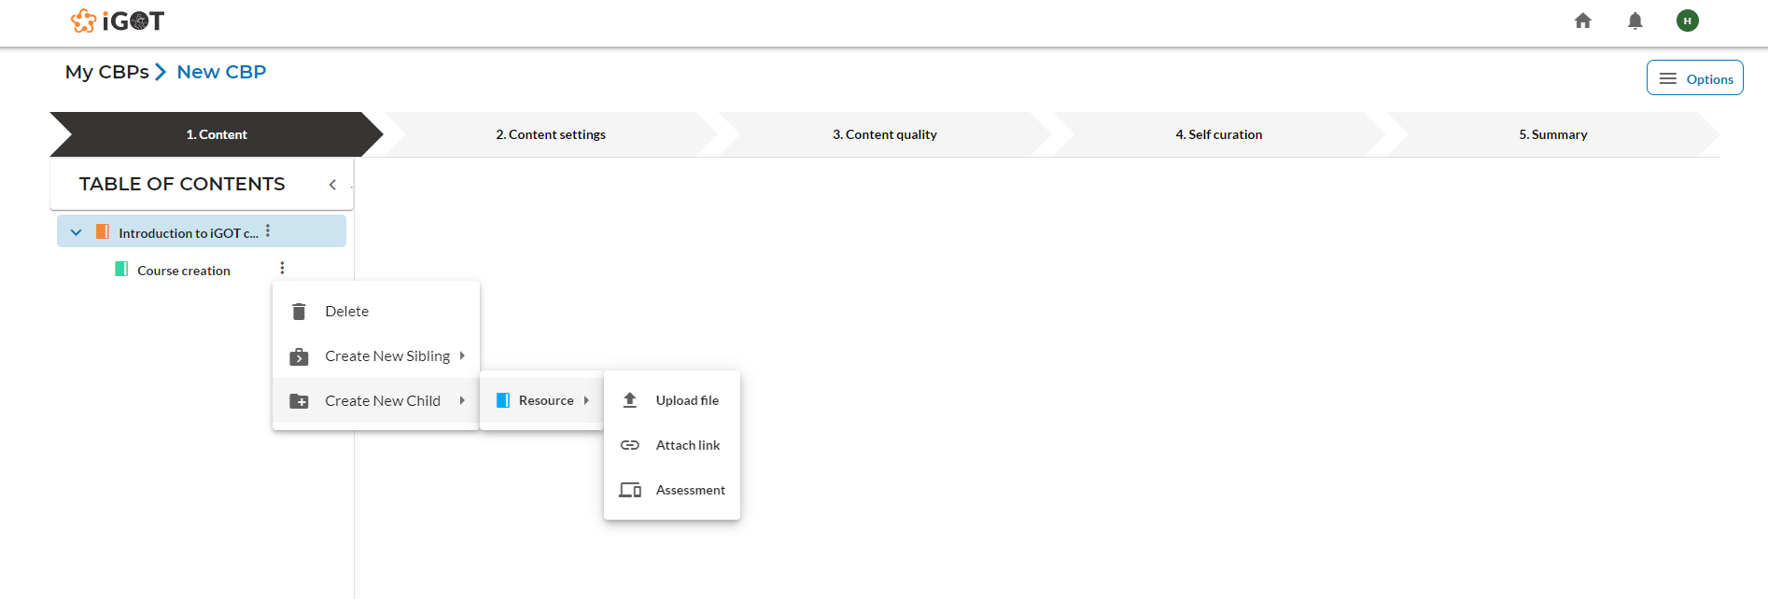

### **2.1.1 Upload file**

Content creator clicks on the “Upload file” option to land on the below screen

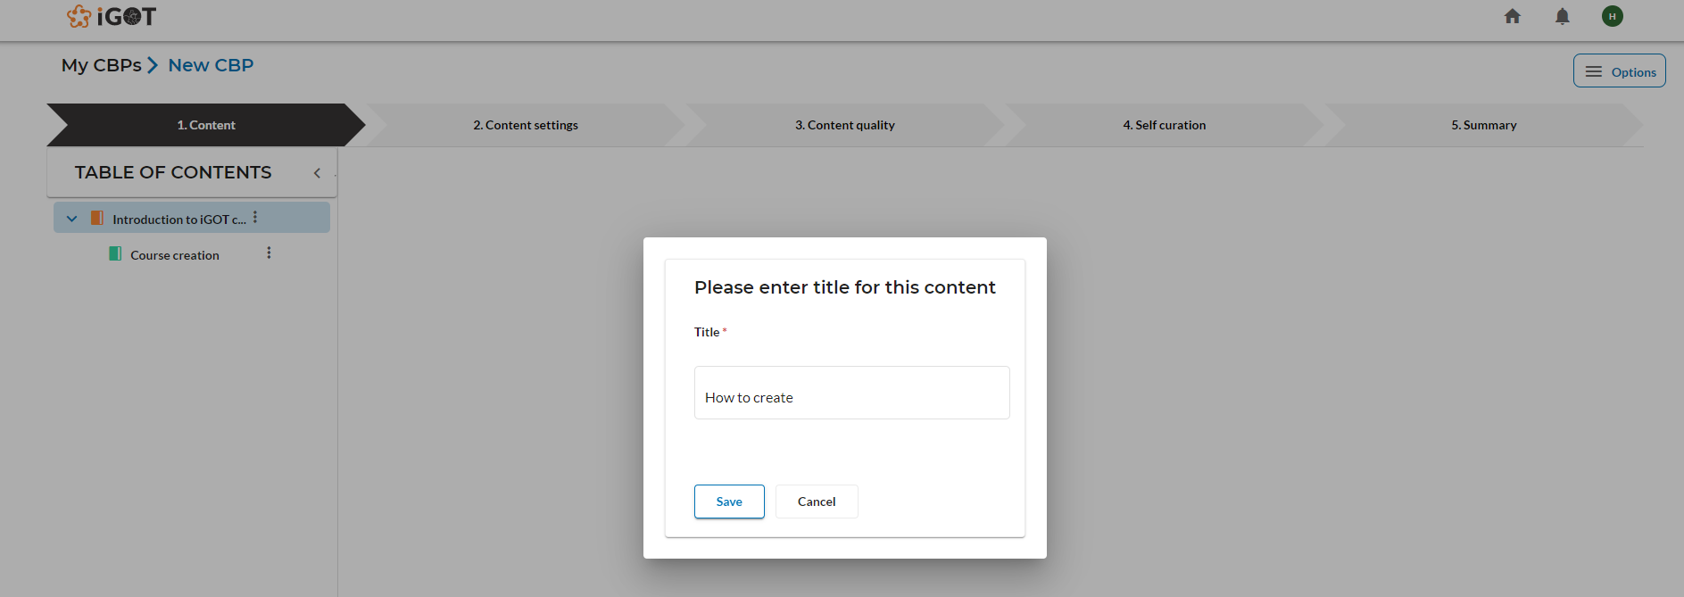

Once the Content creator clicks on “Save” button, the resource will be added and the screen will look as shown below

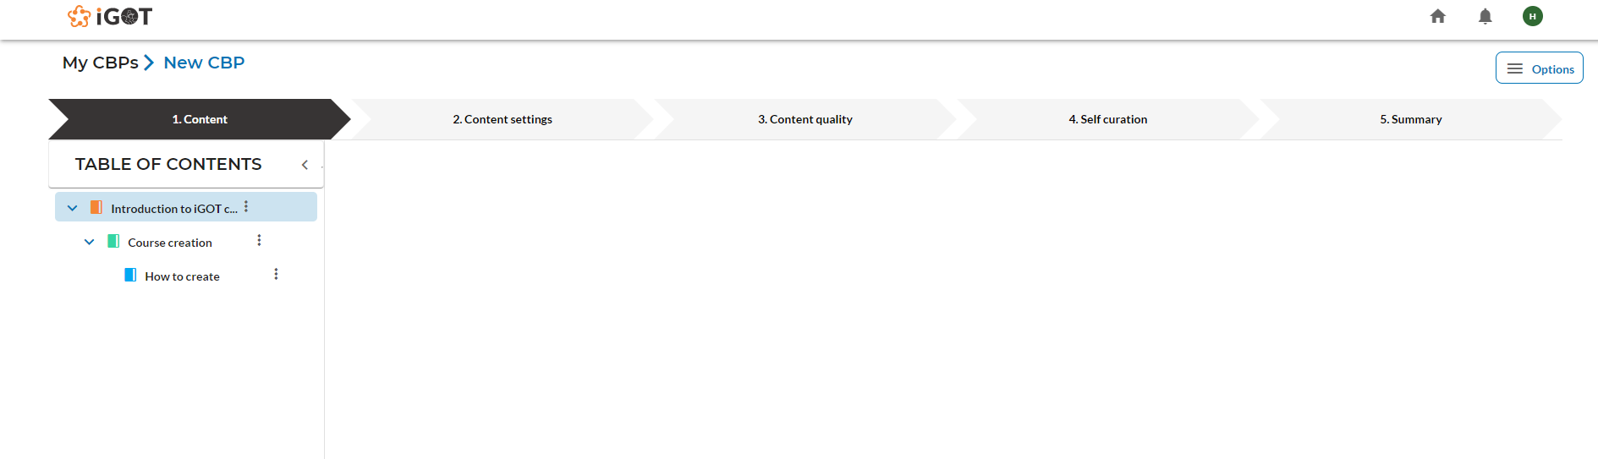

Content creator clicking on the added resource will land on the below screen

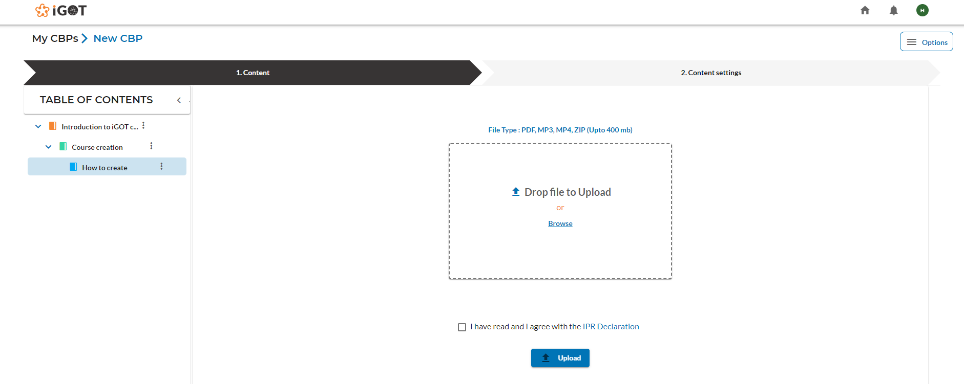

Content creators can click on “Browse” and upload any type of content like MP4, MP3, PDF and ZIP. Once uploaded, the user should check the IPR declaration checkbox then click on the ``Save and proceed” button.

Content creator clicks on save button in “Content settings” tab as shown below to save the uploaded content

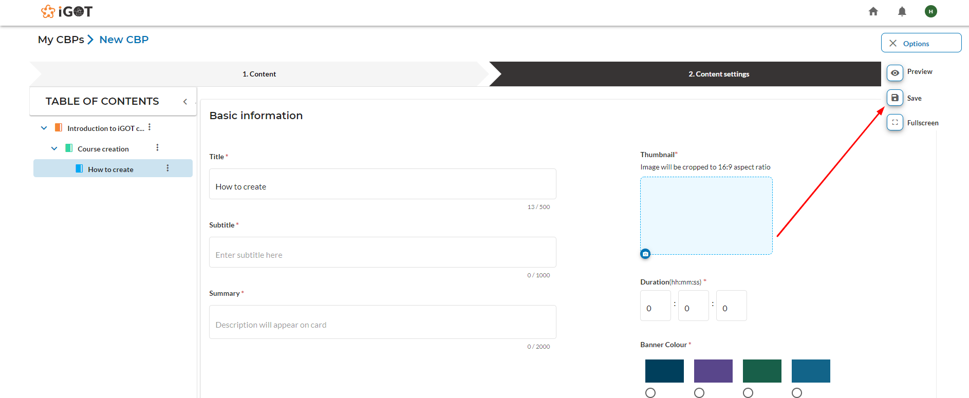

Content creator fills all the mandatory fields in the ‘Content settings’ tab and clicks on the “Save” button as shown in the below screen.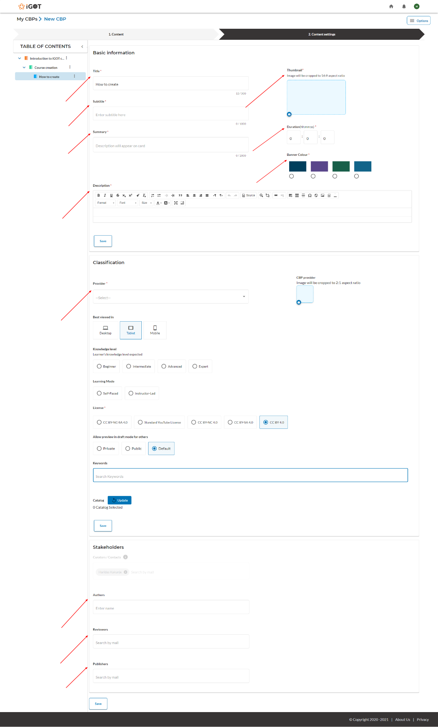

### 

### 

### 

### 

### 

### 

### 

### 

### 

### 

### 

### **2.1.2 Attach a link**

Content creator clicks on three dots next to the course name and selects the attached link of child content for the course to be added.

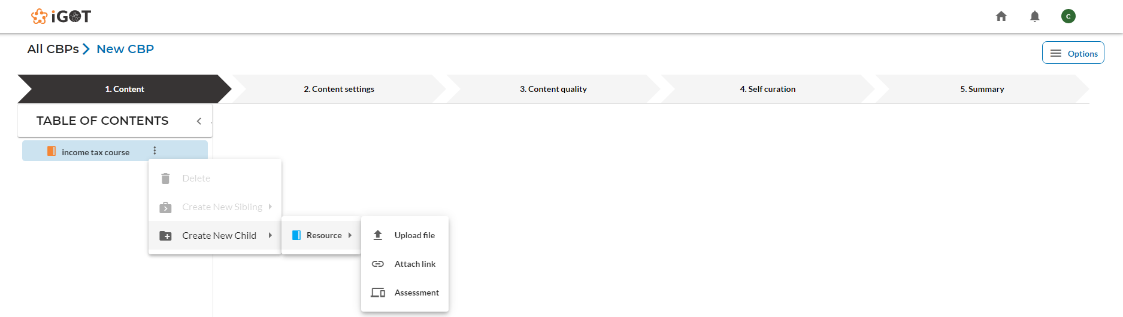

Content creator clicks on the “Save” button after entering the name of the resource as shown below

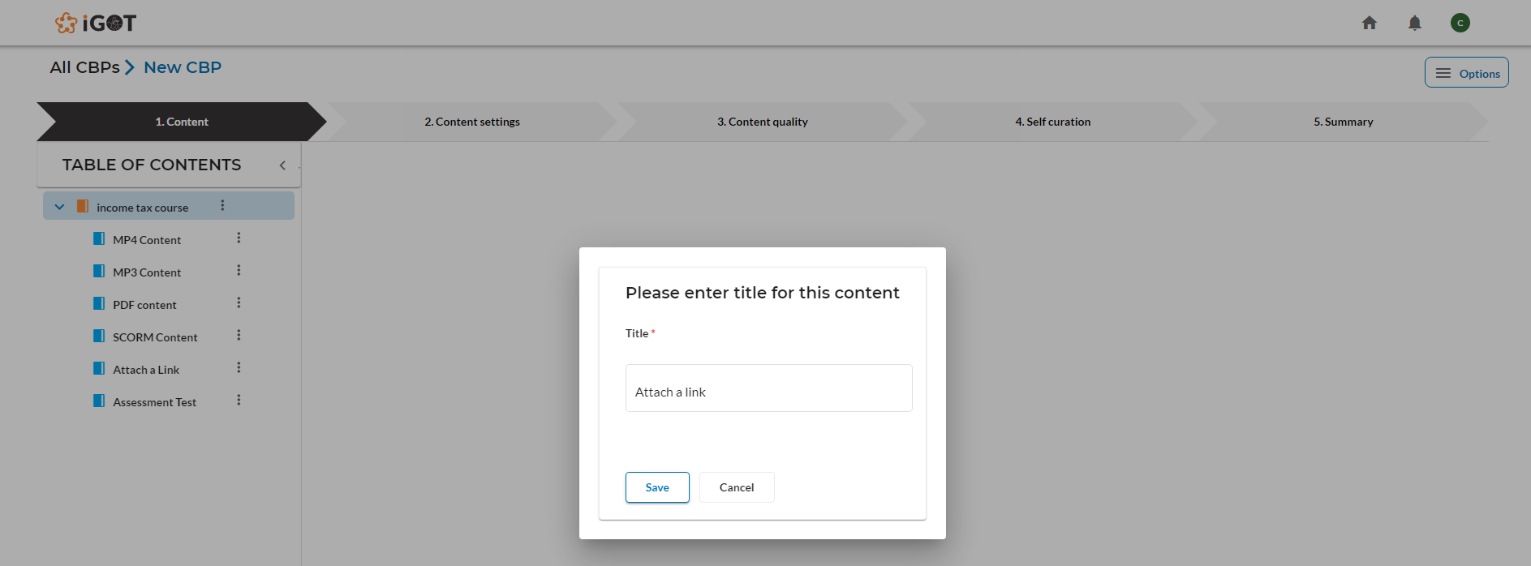

Content creator fills the embedded youTube link, checks the IPR declaration checkbox then clicks on the “Save and proceed” button

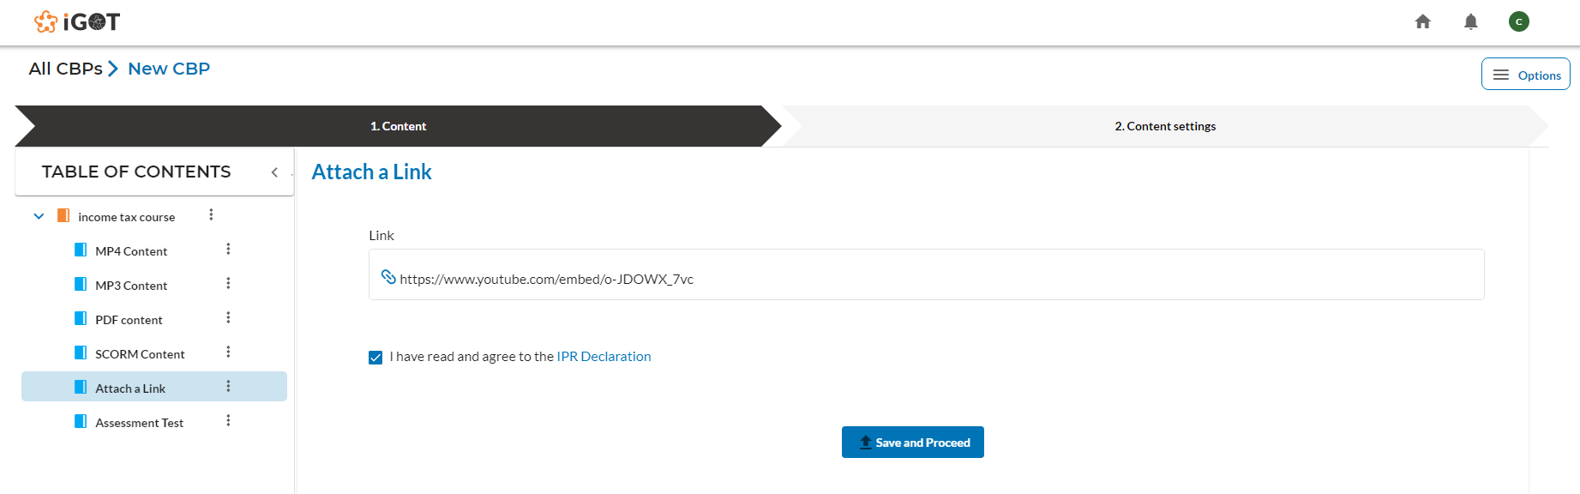

Content creator can fill all the mandatory fields in ‘Content settings’ and click on the “Save” button.

### **2.1.3 Adding an assessment**

Content creator clicks on the three dots next to the course name and selects ‘Assessment’ of child contents for the course being added.



Content creator fills the assessment name and clicks on “Save” button as shown below

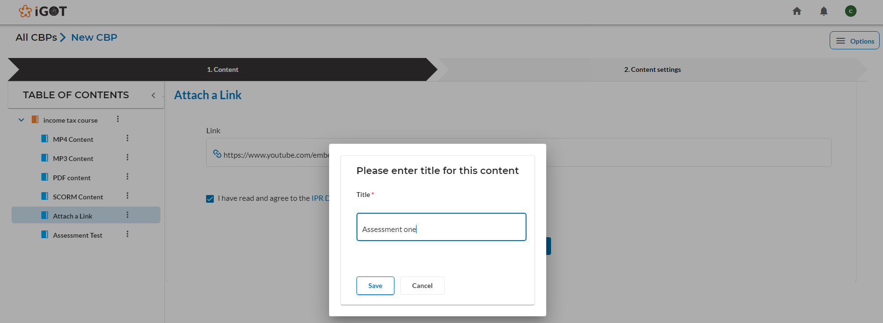

Content creator clicks on add button (+) next to MCQquestion as below

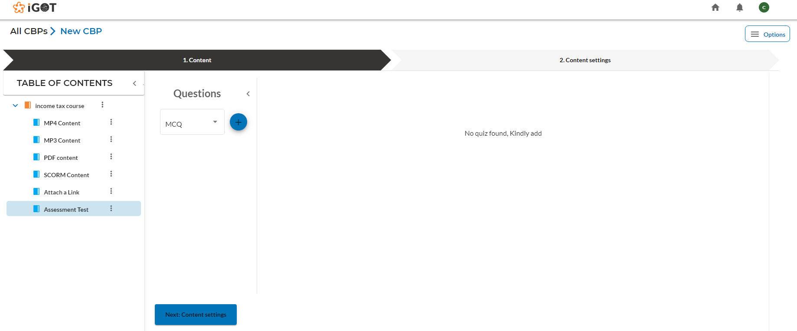

Content creator fills the details of question and options for MCQ created as below

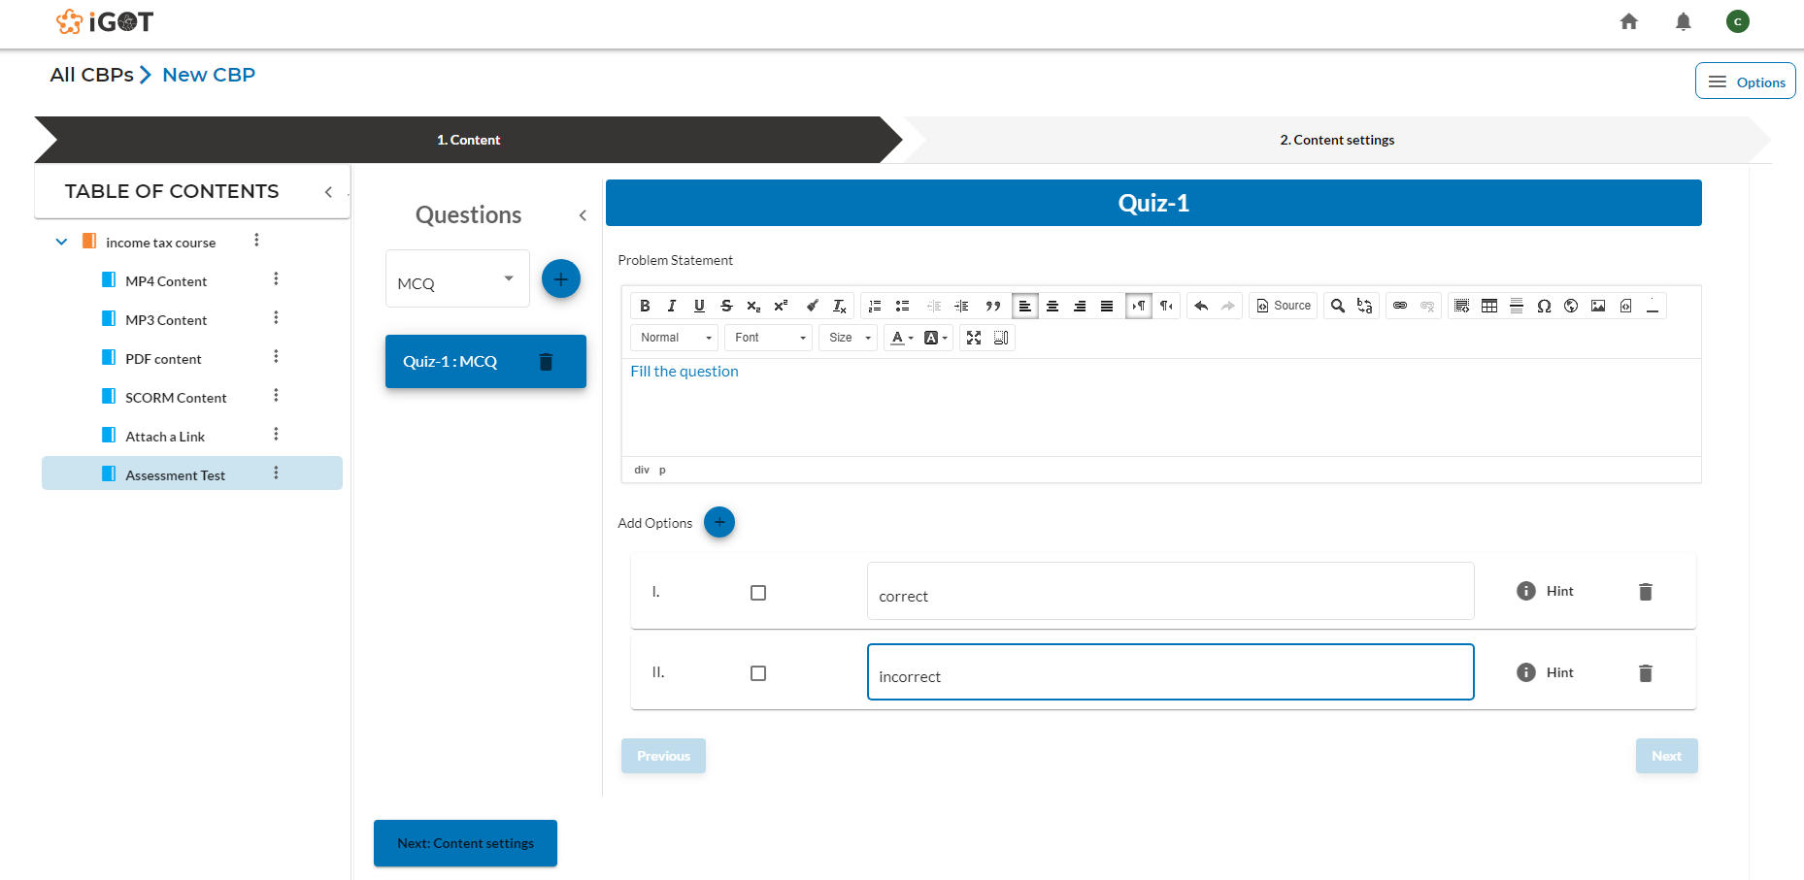

Content creator clicks on the ‘Question’ option and chooses the “Fill in the blanks” option as below screen then clicks on add next to it.

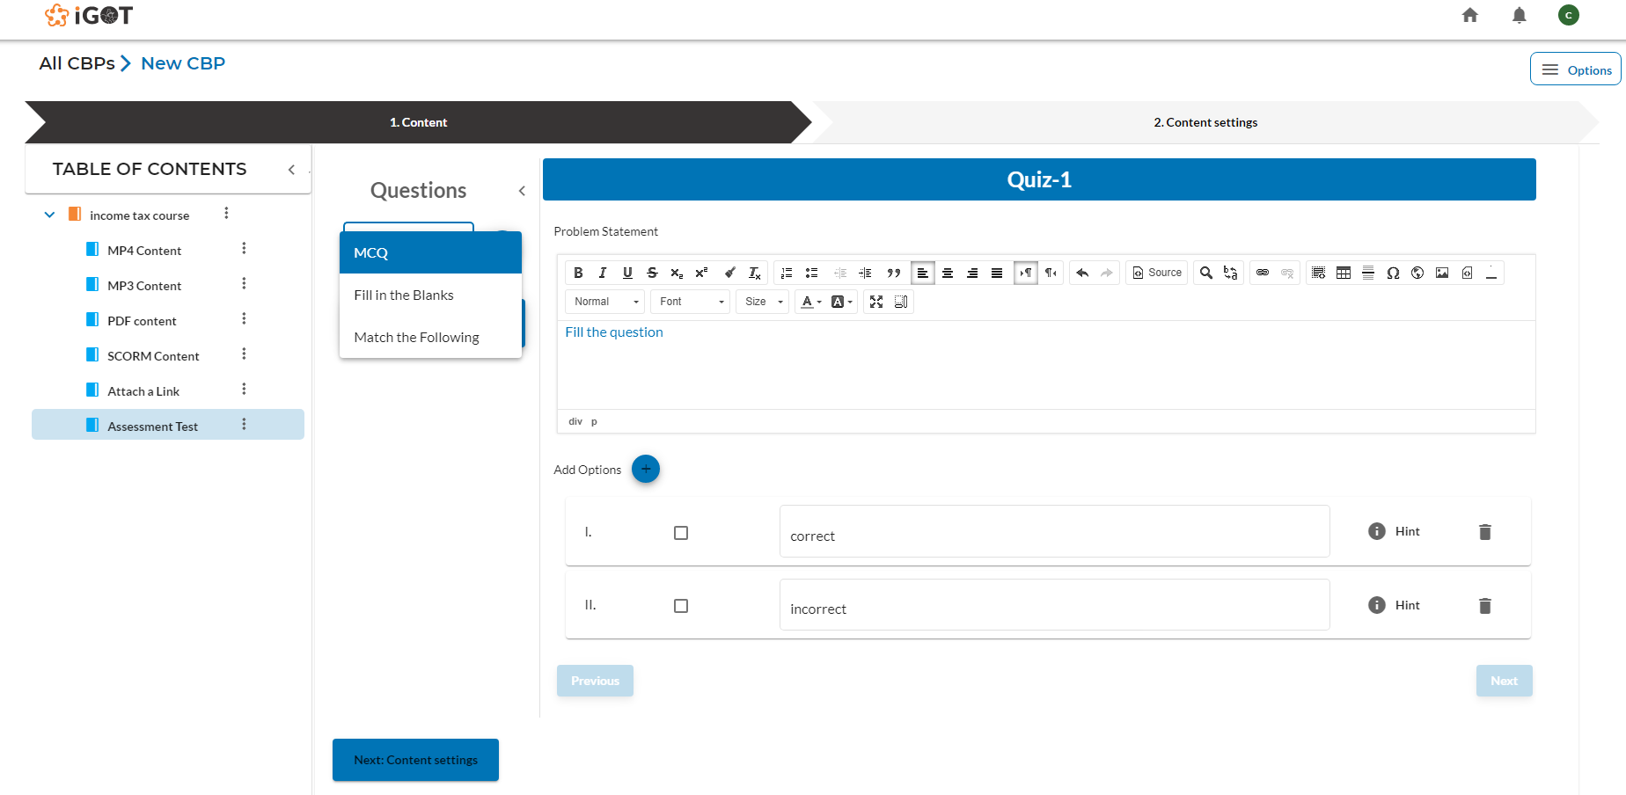

Content creator enter the details of the question in the “Problem statement” section and fills the answer option created as shown below screen

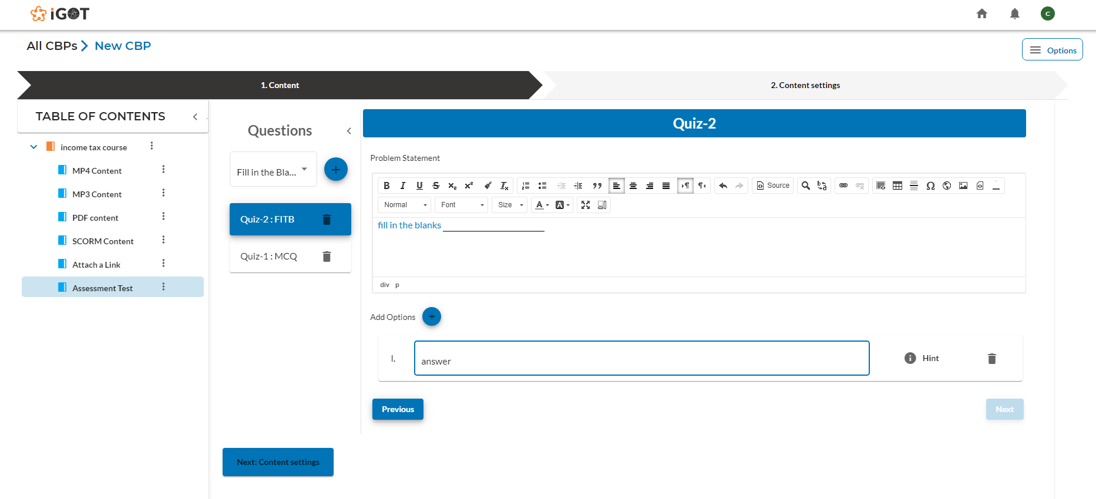

Content creator clicks on the ‘Question’ option and chooses “Match the following” option as below screen then clicks on add next to it.

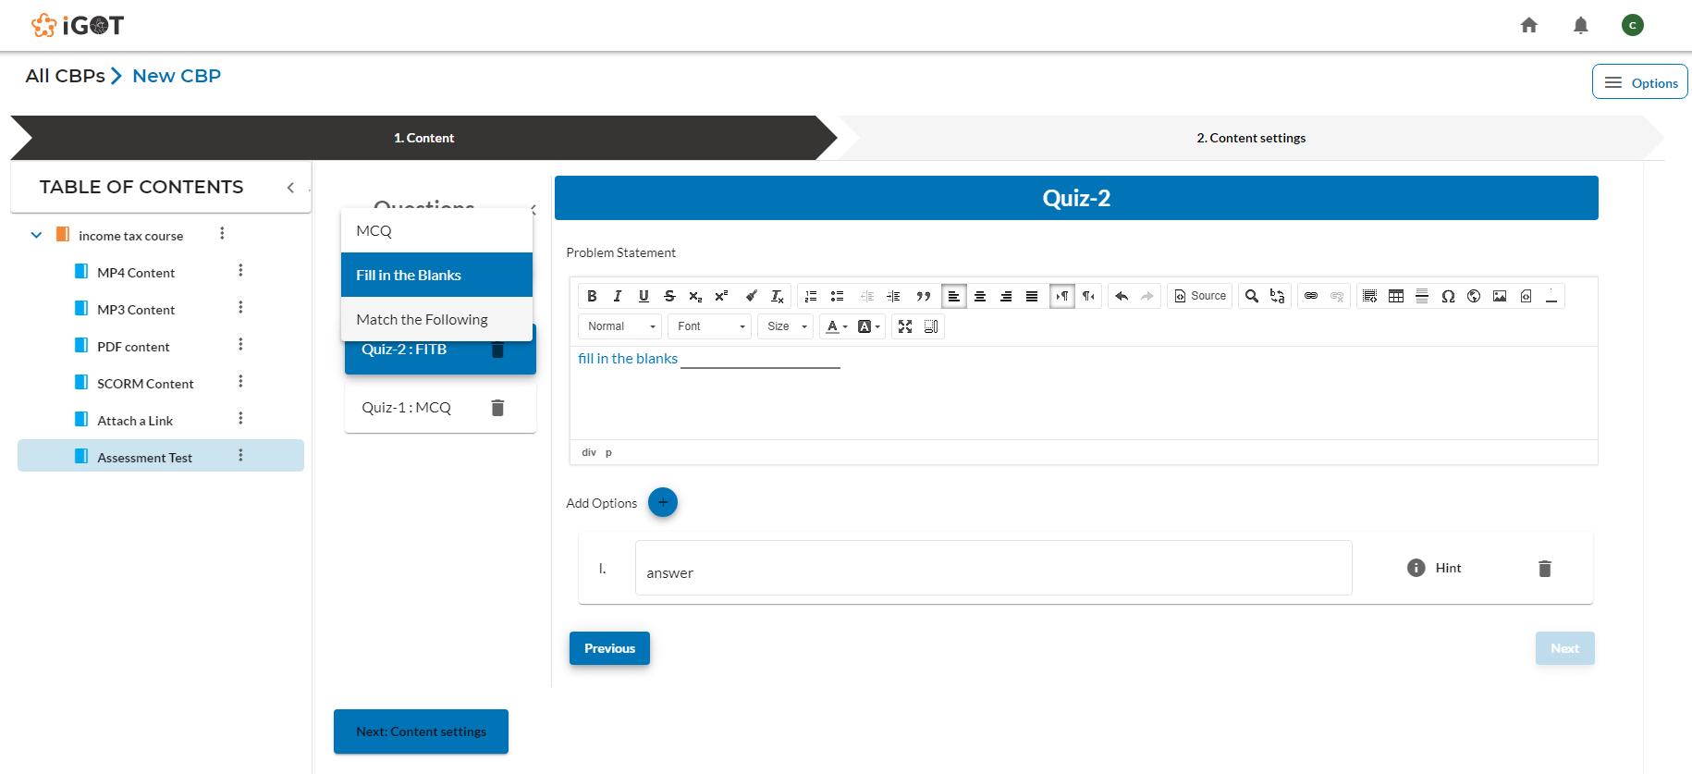

Content creator fills in the details of the question and options for ‘Match the following’ type along with the right answer right next to it as shown in the screen below.

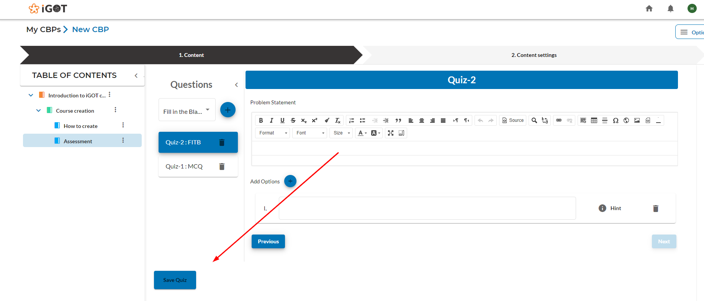

After filling the questionnaires for the resources, the user clicks on the “Save quiz” button to save the questions and navigates to the “Content settings” tab.

### **2.1.4 Content settings**

After adding all the child content under the parent content, the Content creator clicks on the “Content settings” tab for the course and fills in the details like Basics information, Classification, Competencies and Stakeholders .

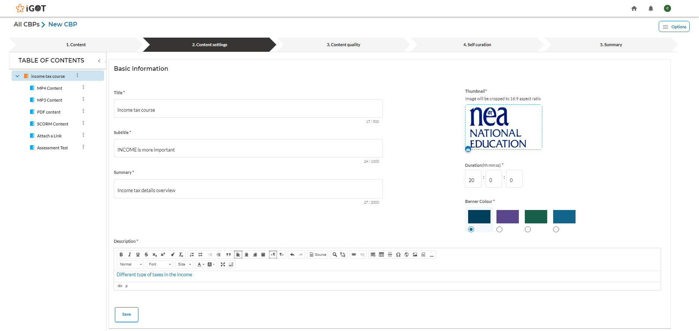

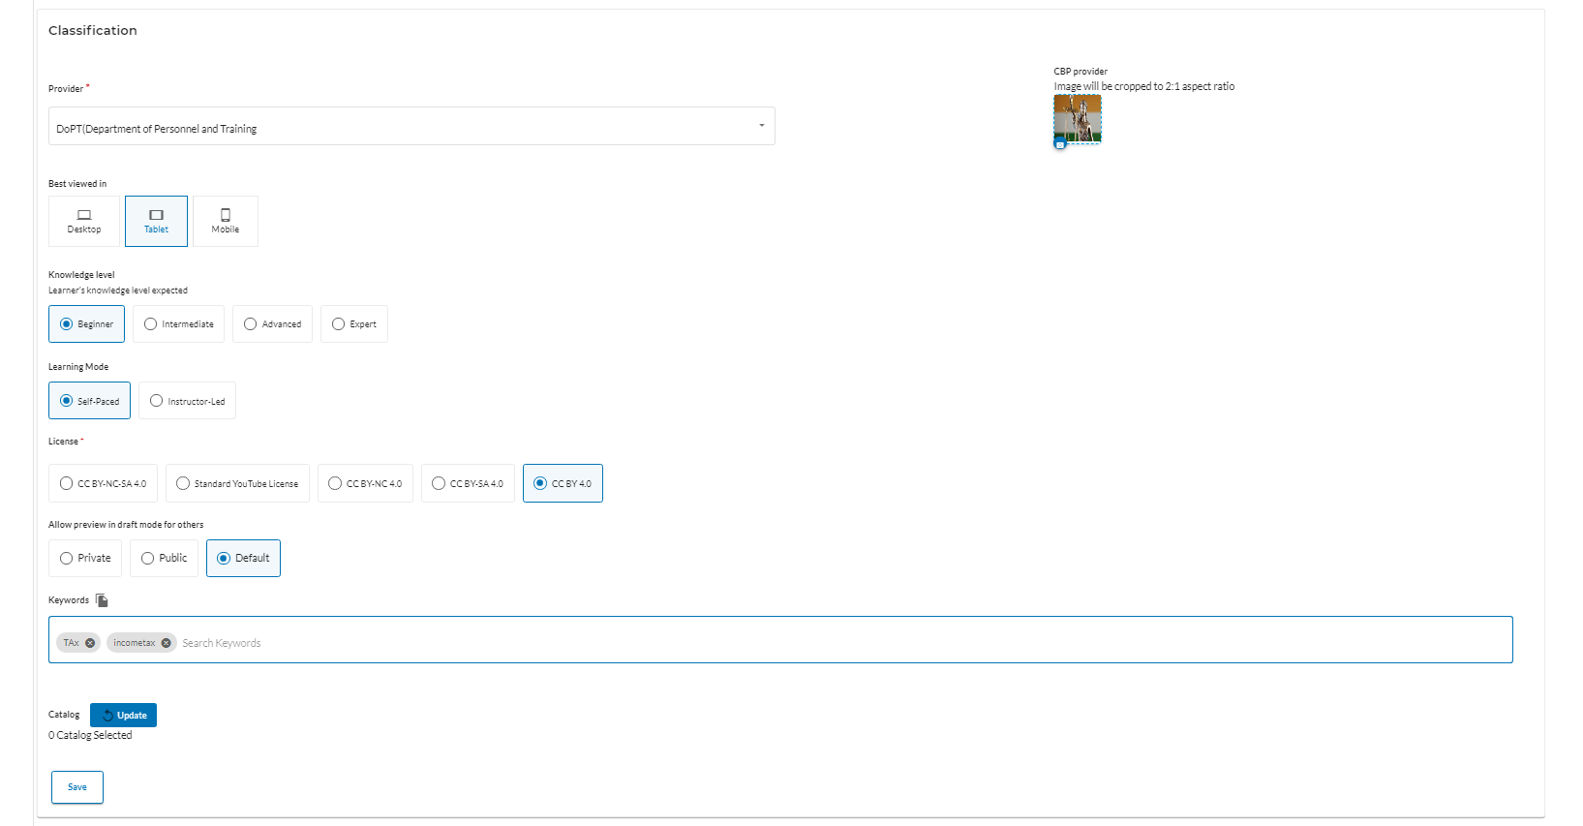

Below, all the competencies present in the FRAC dictionary are displayed.

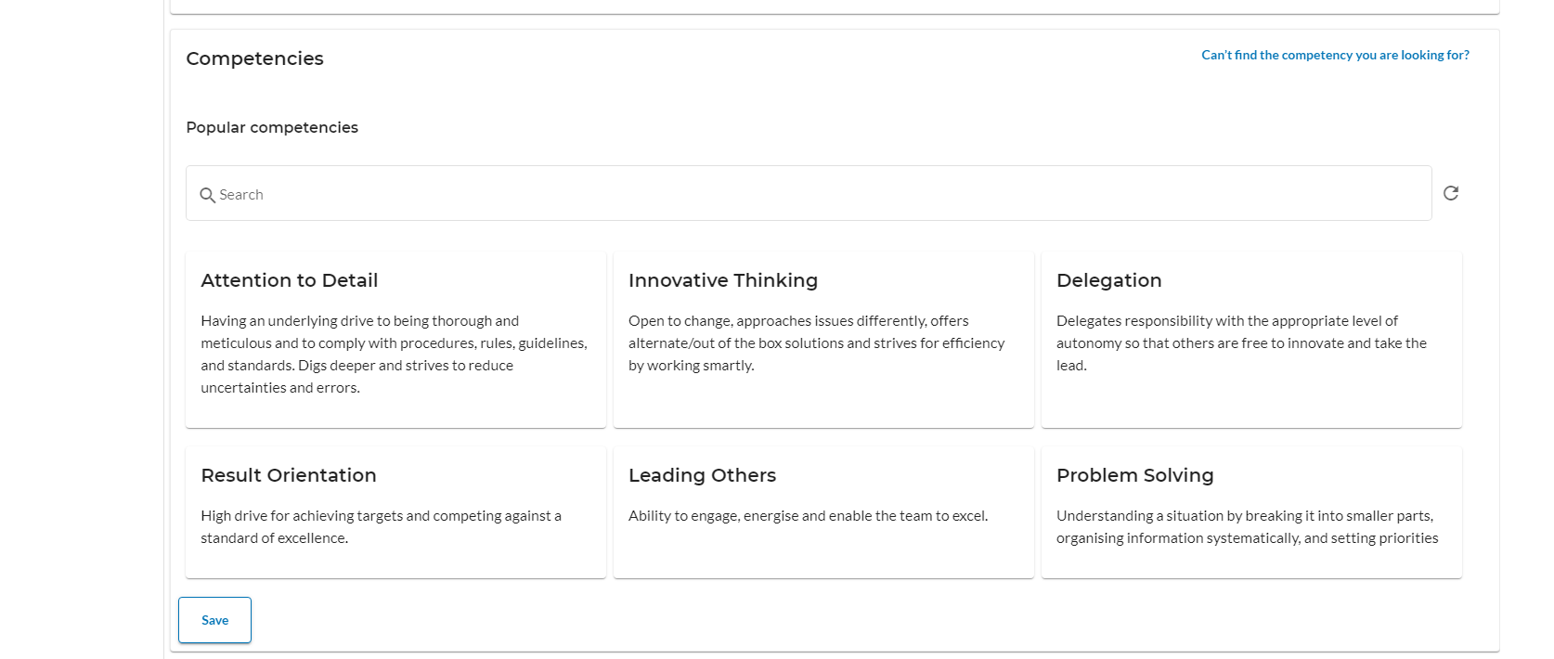

Content creator selects the required competency(s) and clicks on the “Add competency” button to tag those in the course being created.

After the competency(s) gets added, it looks like the screen below. Content creator clicks on the “Save” button in the below form to save the tagging of competency.

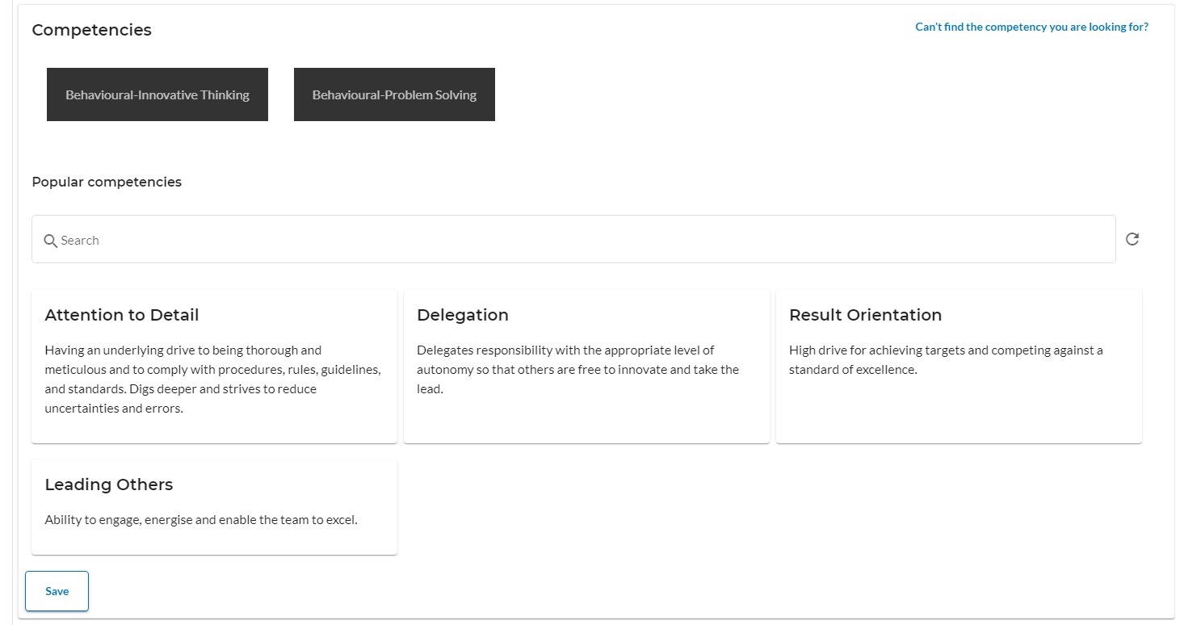

Content creator adds the author, reviewer and publisher for this content and then clicks on the “Save” button below the form.

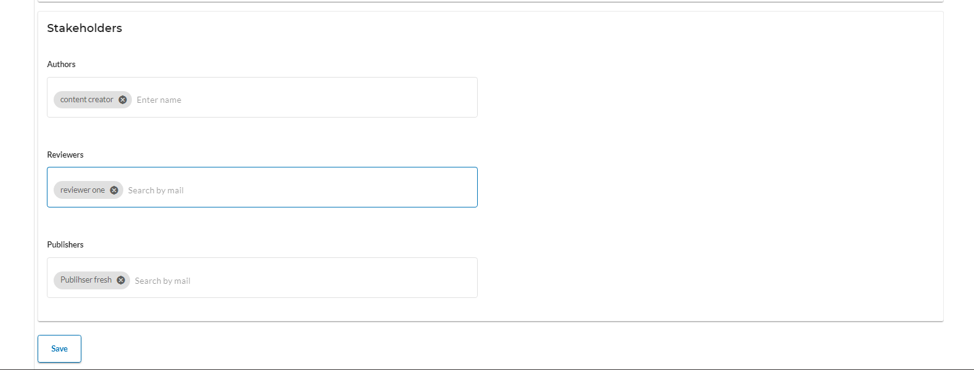

### **2.1.5 Content quality**

Content creator clicks on the “Content quality” tab after filling all details under ‘Content setting’ for validating the content quality score.

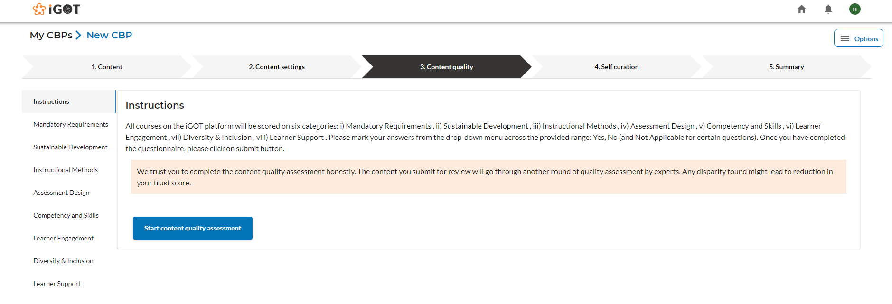

Content creator click on the “Start content quality assessment” button to start the content quality check.

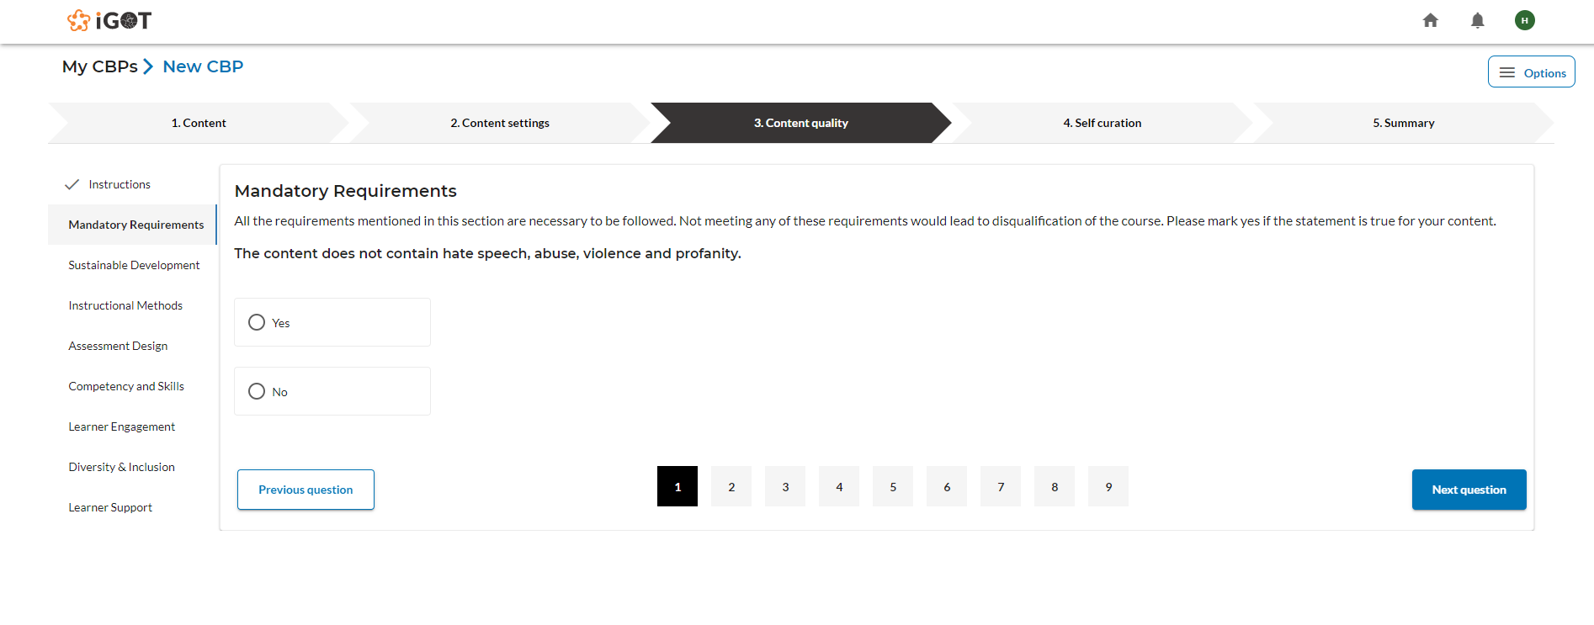

Content creator takes the assessment by answering the questions under the 7 sections and then clicks on the “Submit” button at the last to get the content quality score.

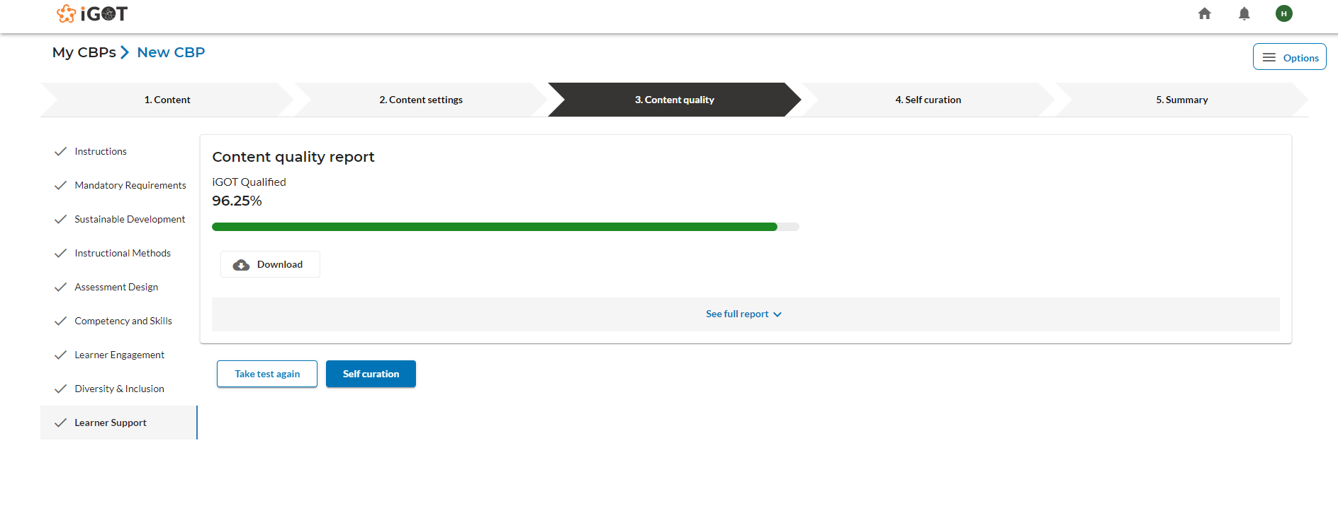

* Only when the content quality score is equal to or higher than 70% , the content will be send to review from drafts
* Also, all the 7 sections need to individually have at least 70% or more content quality score.

If neither of the above conditions are satisfied, the Content creator has to take the test again by clicking the “Take test again” button inorder to satisfy the above two conditions.

Note:

During the review of the course , the Reviewer also should do a content quality check.

### **2.1.6 Self curation**

Content creator clicks on the “Self curation” tab once the above two conditions for the content quality score are met.

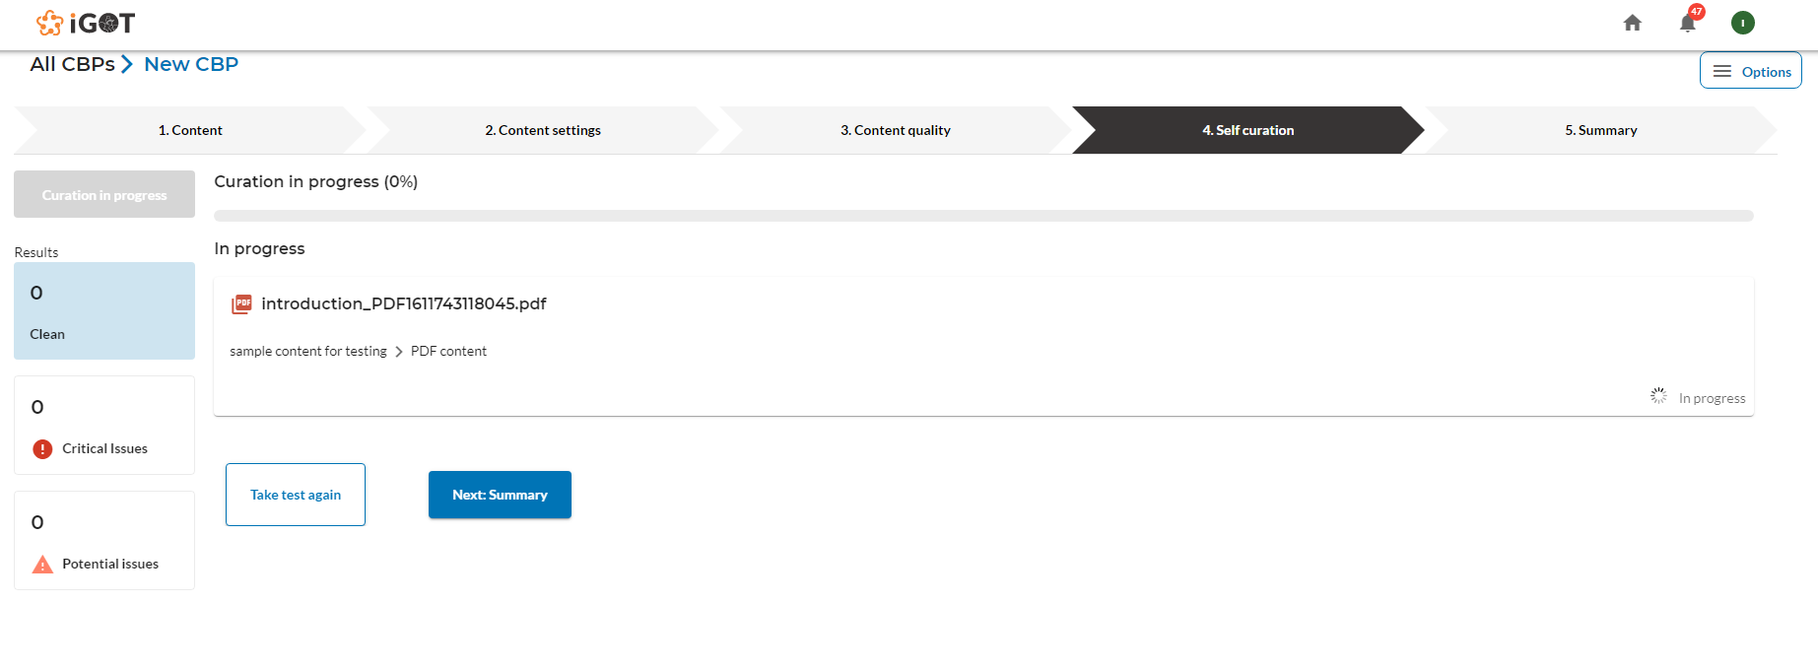

This self curation will be displayed only if the content contains any pdf type of content.

Profanity services have been integrated here in order to find offensive words in pdf content.

Profanity service scans the words in all pages of the pdf. There is a progress bar that indicates the completion of the curation process.

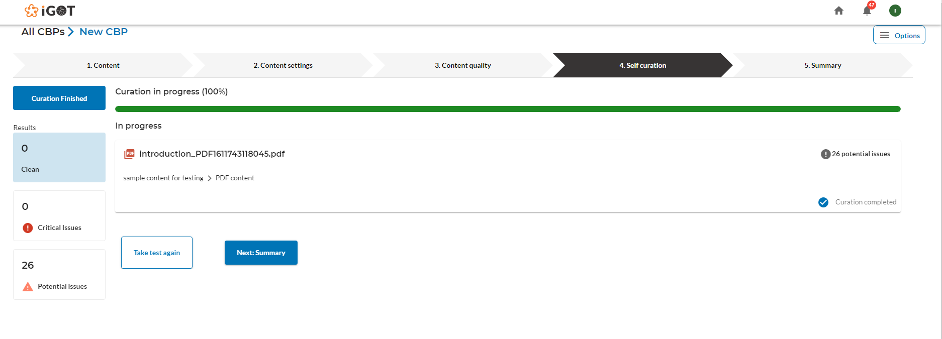

Content creator click on the potential issues next to the PDF to see the words used in the pdf.

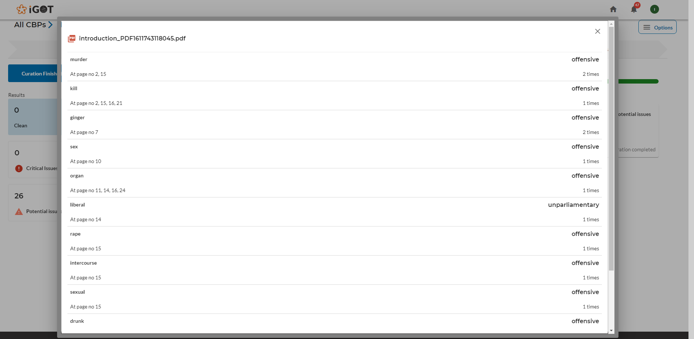

Content creator clicks on the “Next: Summary” button to move to the summary tab.

### 

### 

### **2.1.7 Summary**

Summary of the course is displayed in the “Summary” tab.

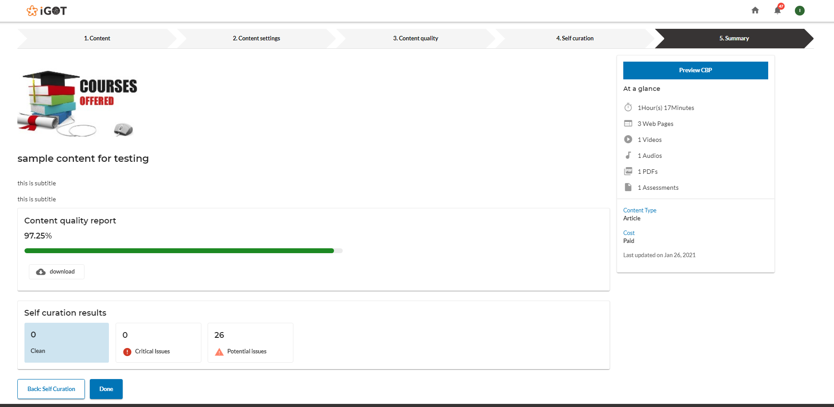

Content creator clicks on the “Preview CBP” button to preview the content.

Content creator either clicks on the “Options” button and selects the “Send for review” option inorder to send the content for review as shown below .

Alternatively, the user can click on the “Done” button.

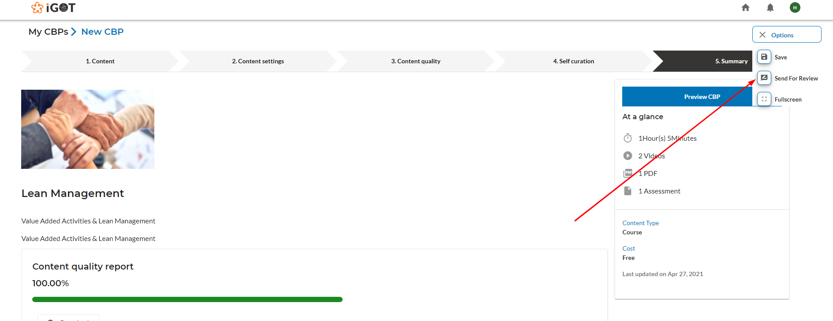

Clicking on either the “Send for review” or “Done” button, the Content creator will land on the below screen where the content creator can add the comments and click on their “Proceed” button.

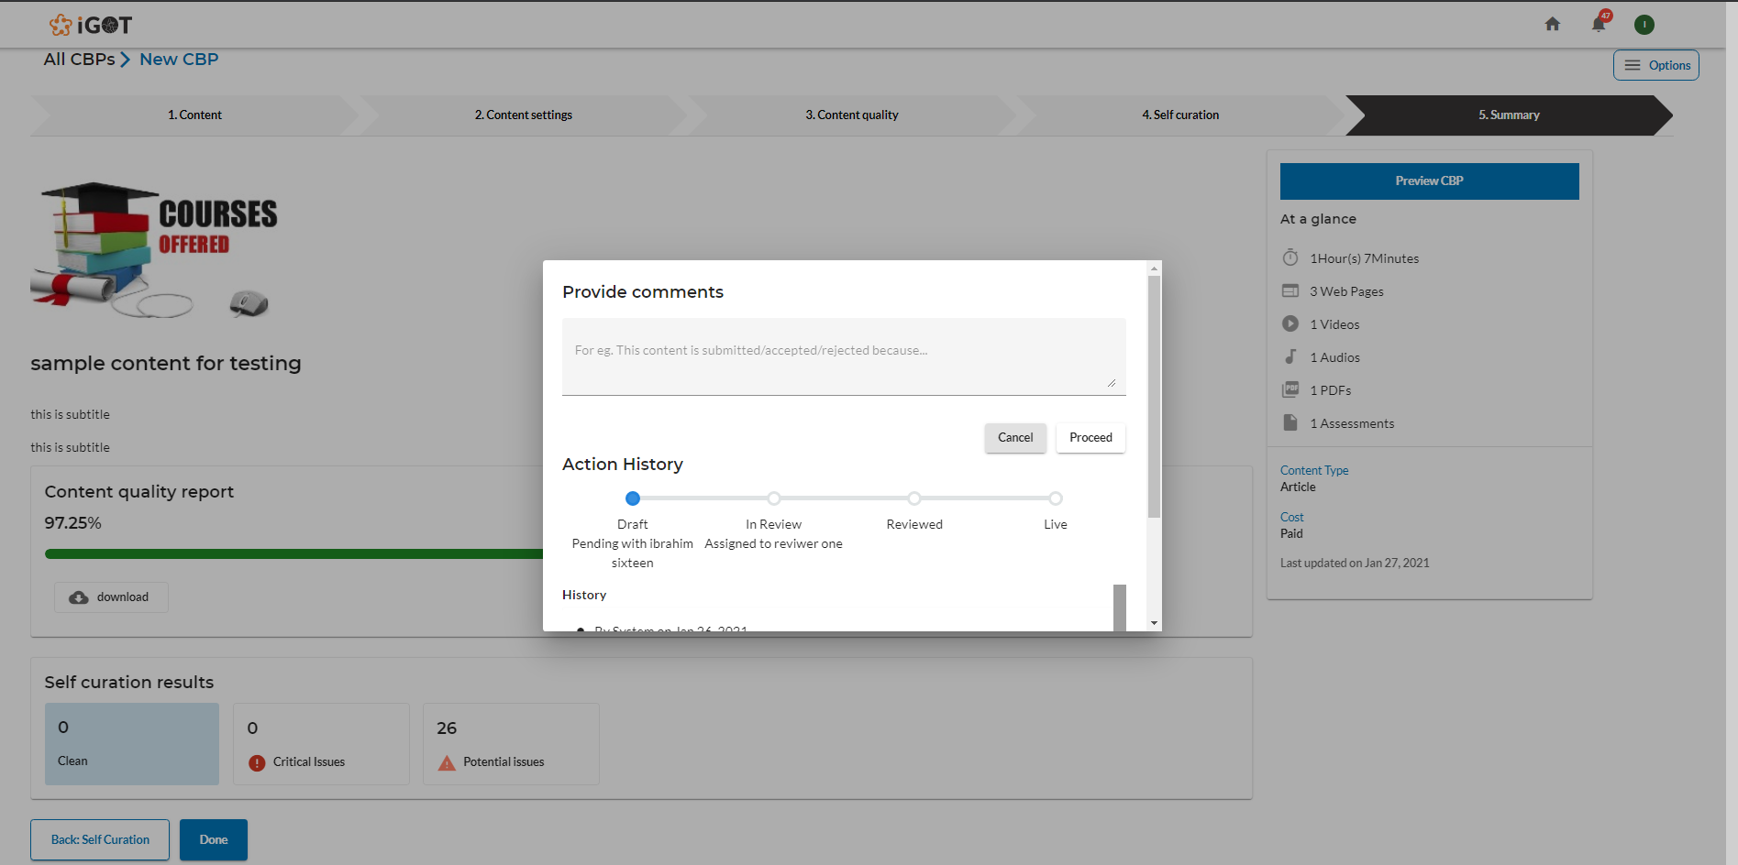

Courses created by the content creator will be saved under the “Drafts” tab of “My CBP’s” once it is saved.

## **2.2 Review & Publishing**

As the reviewers login to the CBP portal , there will be two tabs in home screen as:

1. Live: Once the courses are reviewed and published it will be displayed in the “Live” tab
2. For review: Courses that need to be reviewed will be displayed in the “For review” tab

Reviewer click on “For review” tab and lands on the below screen

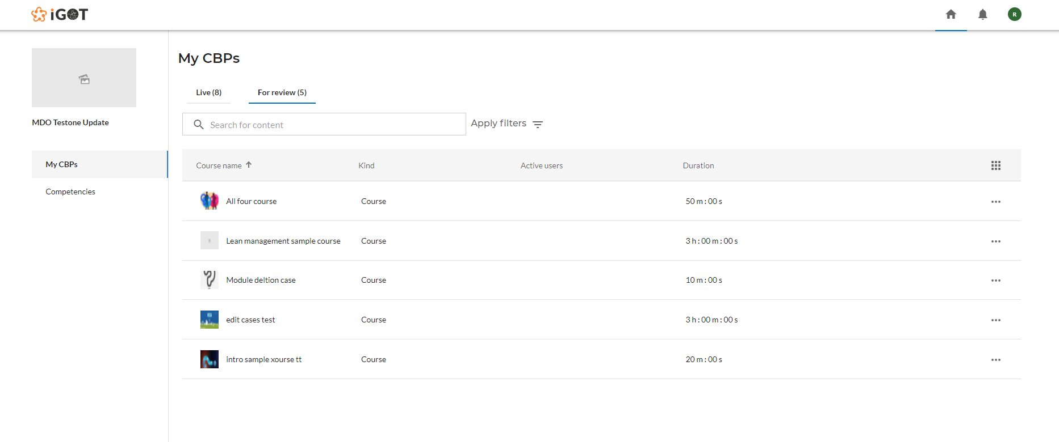

To review the course , click on the “three dots” as shown below and select “Review”

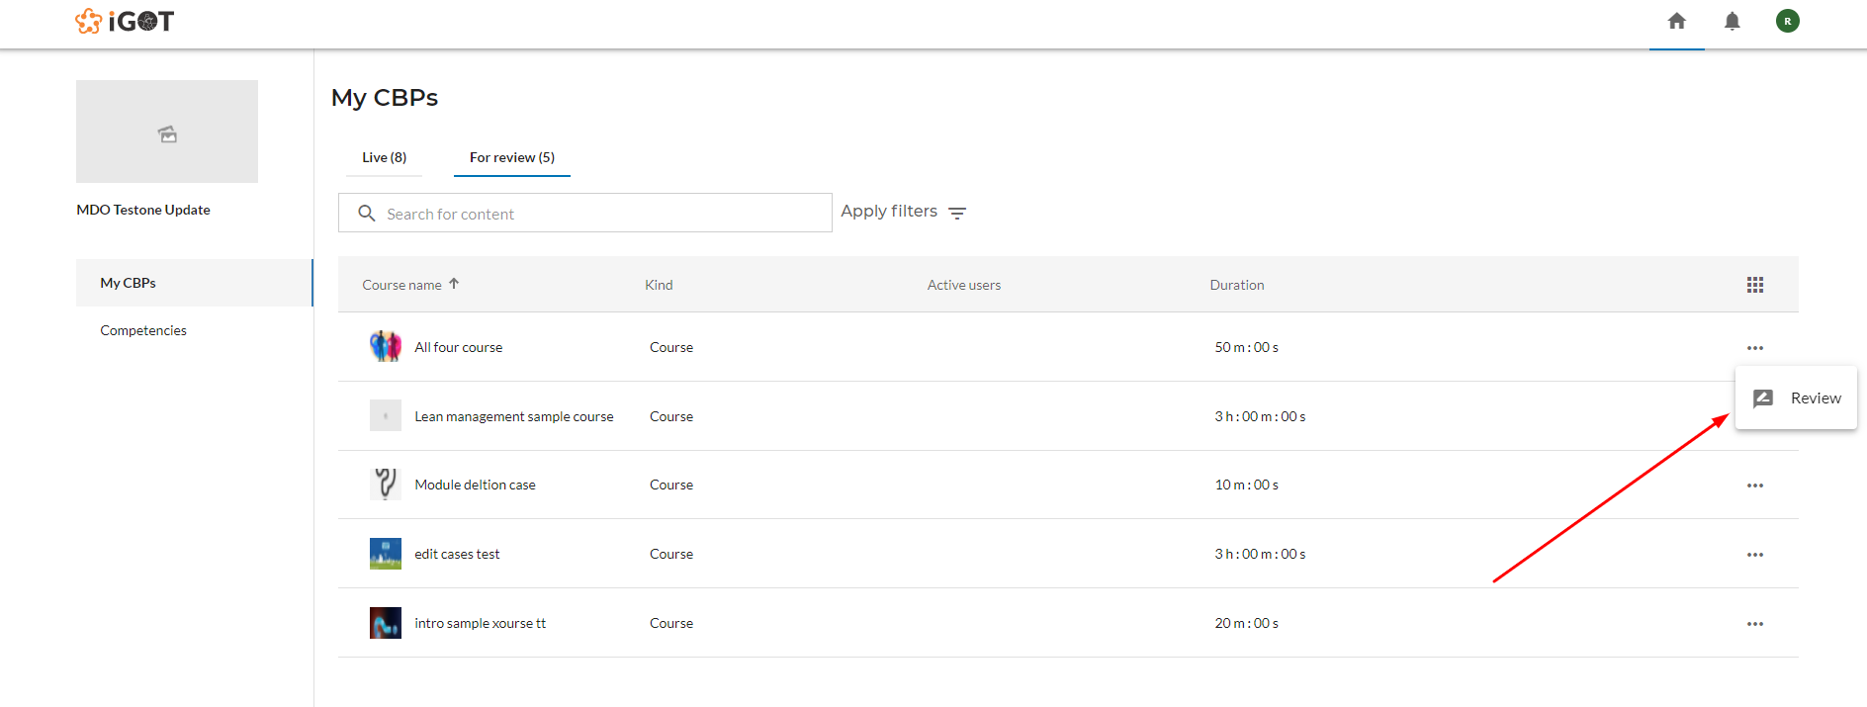

Reviewer can view all the course content and take the content quality check in “Content quality”tab by clicking on the “ Take test again” button as shown below

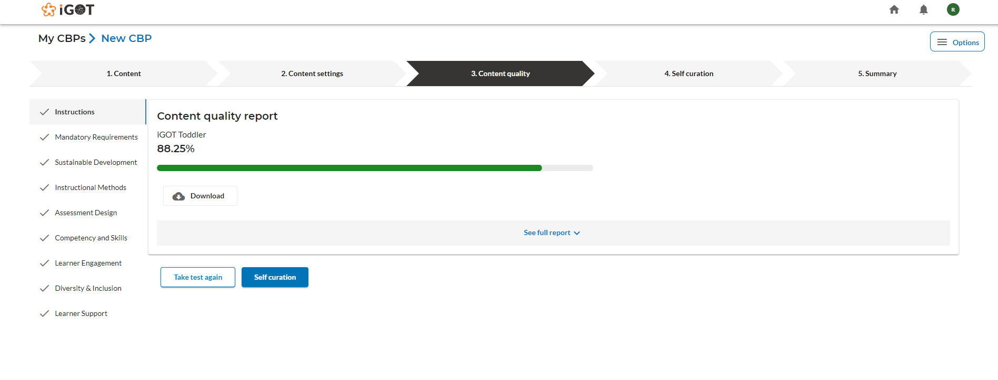

Once the course is reviewed, reviewer clicks on the “Options” button and selects “Publish” as shown below

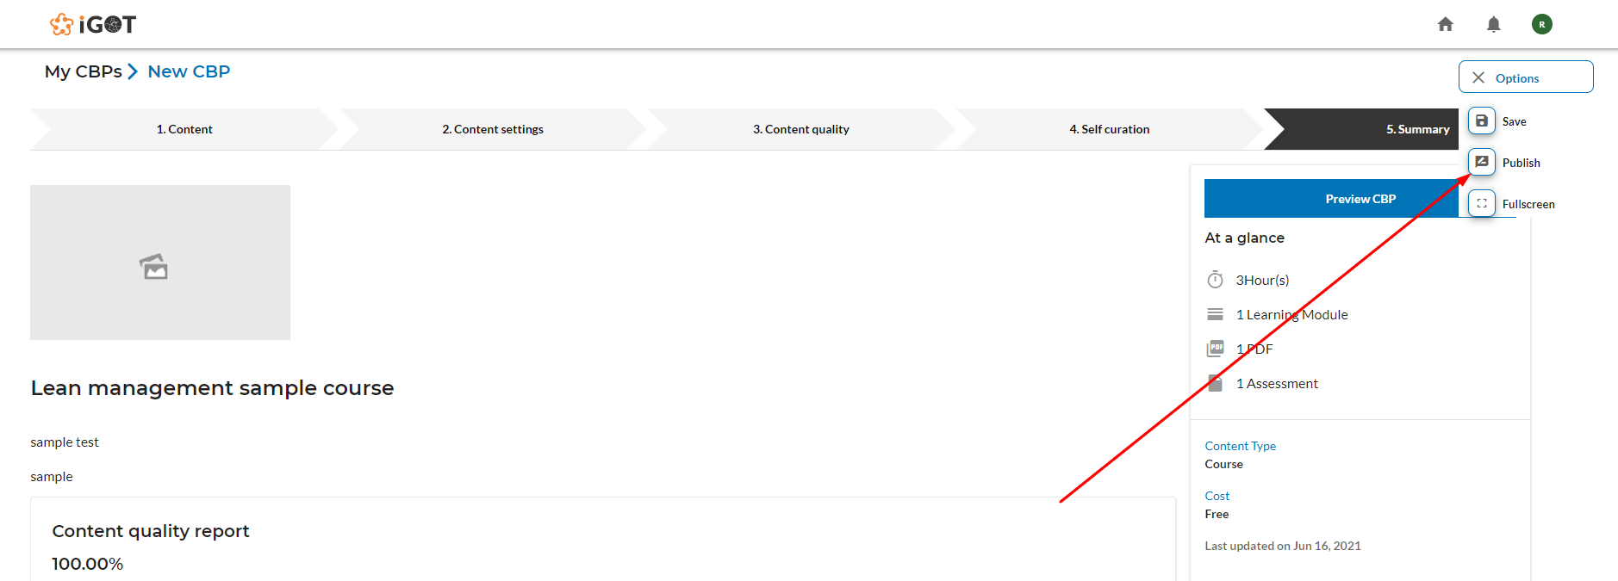

Reviewer clicking on “Publish” will land on the below popup where there is a provision to either accept or reject the course .

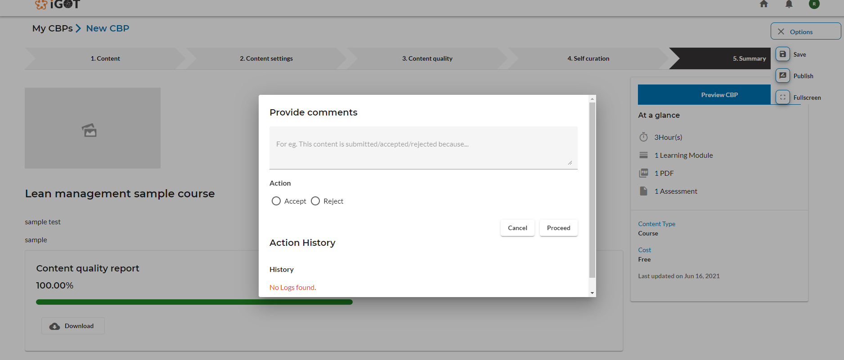

Reviewer selects “Accept” and clicks on the “Proceed'' button. The course is then displayed under the “Live” tab as shown below

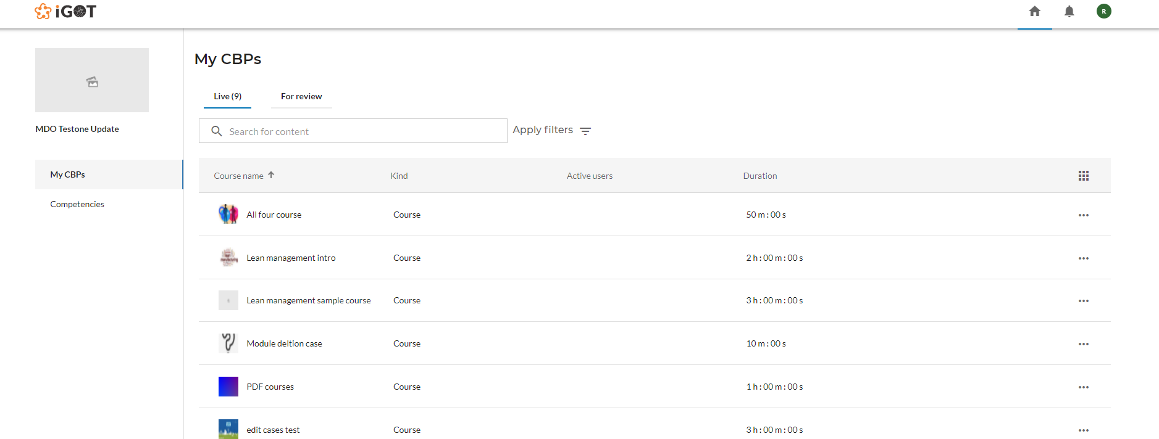

*NOTE: Currently publishing is a 2 step process, where reviewers are the one who publish the content.*

## **2.3 Editing & Unpublishing**

Content creators clicks on the three dots as shown below will have two options to choose. Either they can edit the existing content or unpublish the already published content.

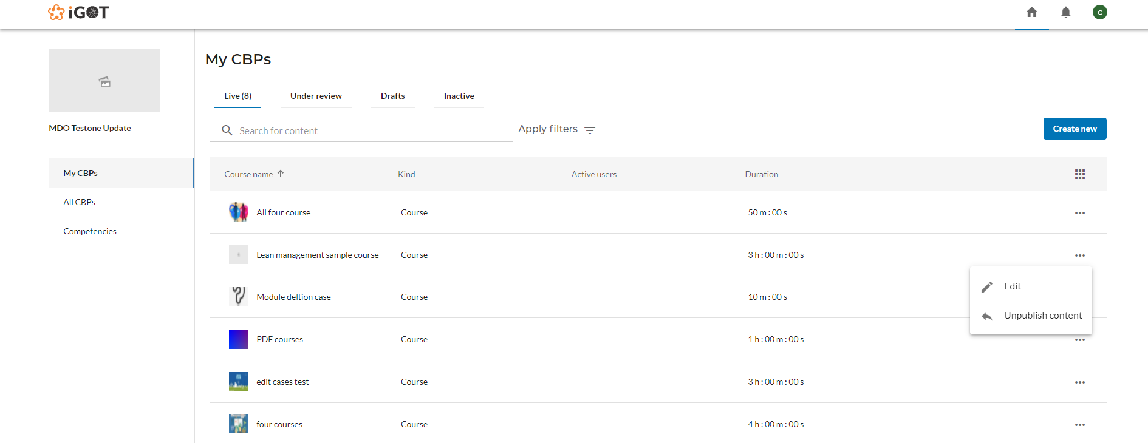

Edit course:

On click of the “Edit” button, the content creator lands on the below screen where user can make the necessary changes to course/resources and again sent it for review.

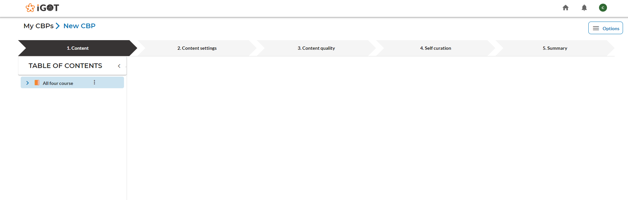

Content creator clicks on the “Options” and selects the “Sent for review” option.

Unpublish course:

As the user clicks on the “Unpublish” button, a confirmation popup will be displayed as below.

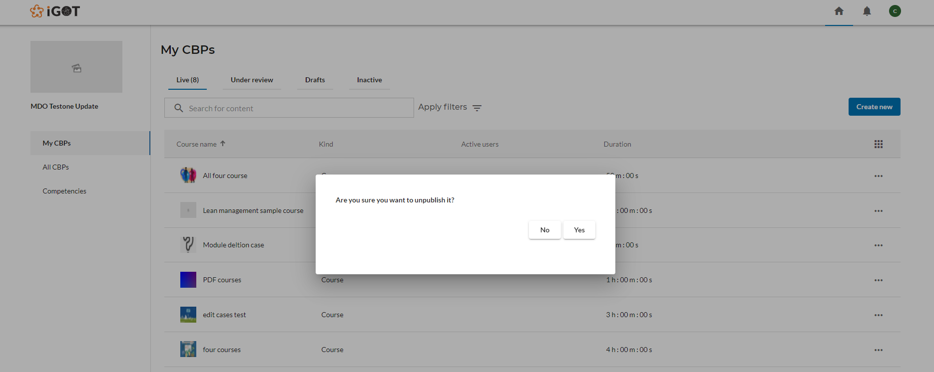

Content creator clicks on the “ Yes” option from the popup to unpublish the content and the course will be displayed under the “Inactive” tab as shown below.

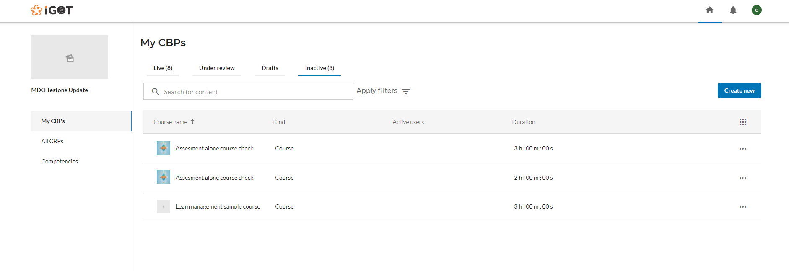

## **2.4 My CBPs**

Contents created by the logged in CBP provider user is displayed under ‘My CBPs’

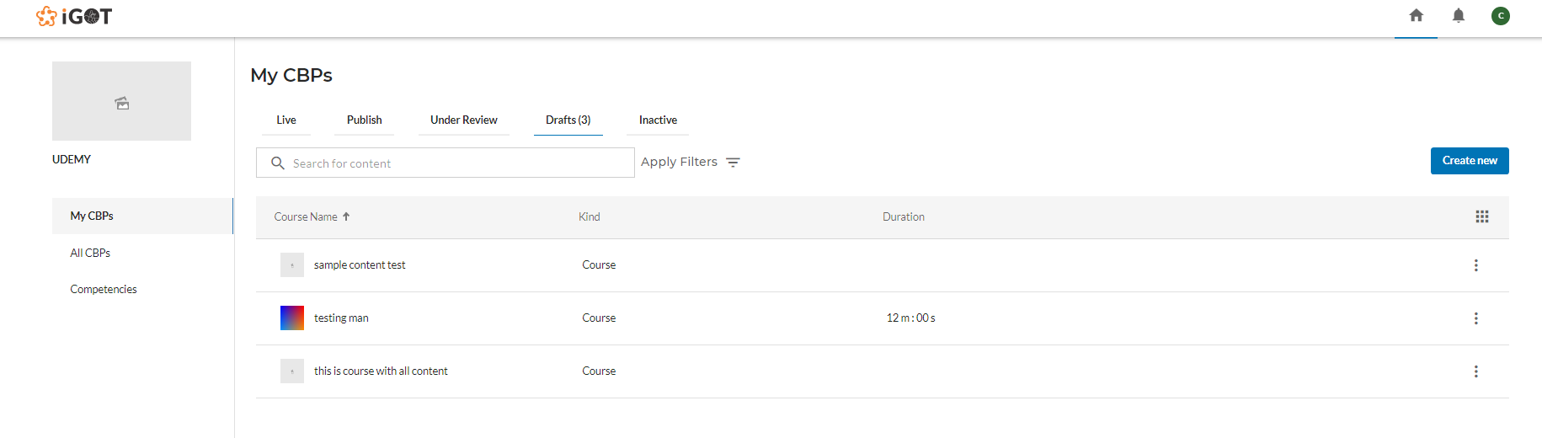

## **2.5 All CBPs**

Content created by other users of the logged in user’s MDO is displayed under ‘All CBPs’.

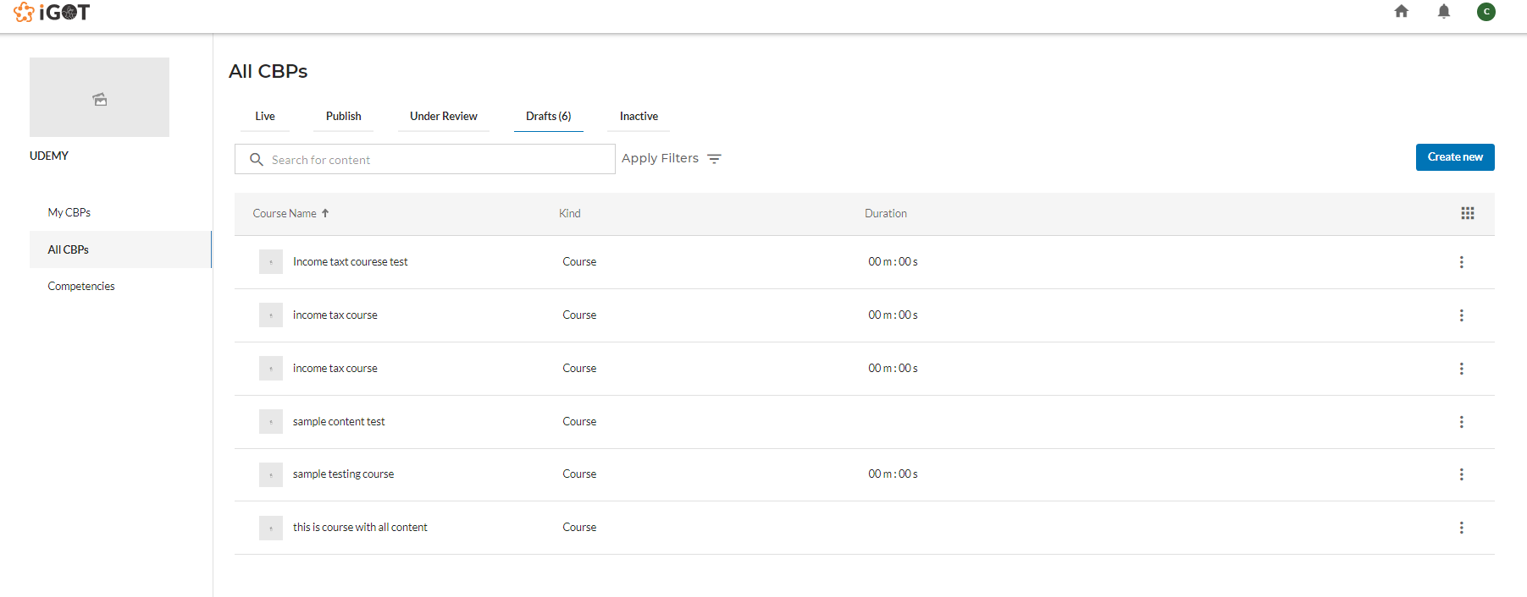

## **2.6 Competencies**

CBP portal users can see the list of verified competencies by the FRAC review board under the “Competencies” menu on the left side.

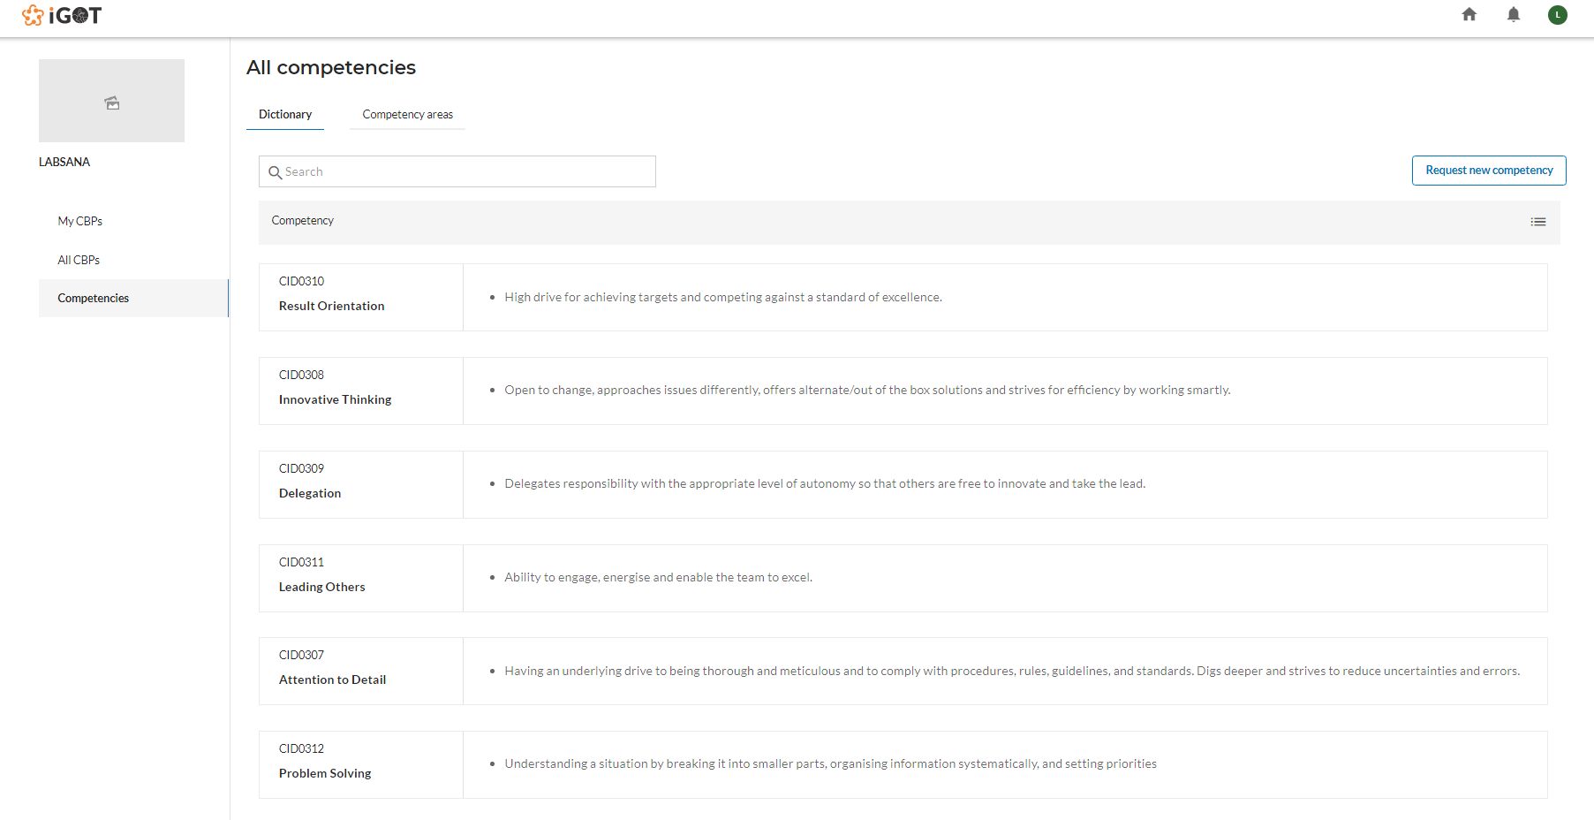

Under the ‘Dictionary’ tab, the user clicks on any one of the competencies in the list to see the details of that competency.

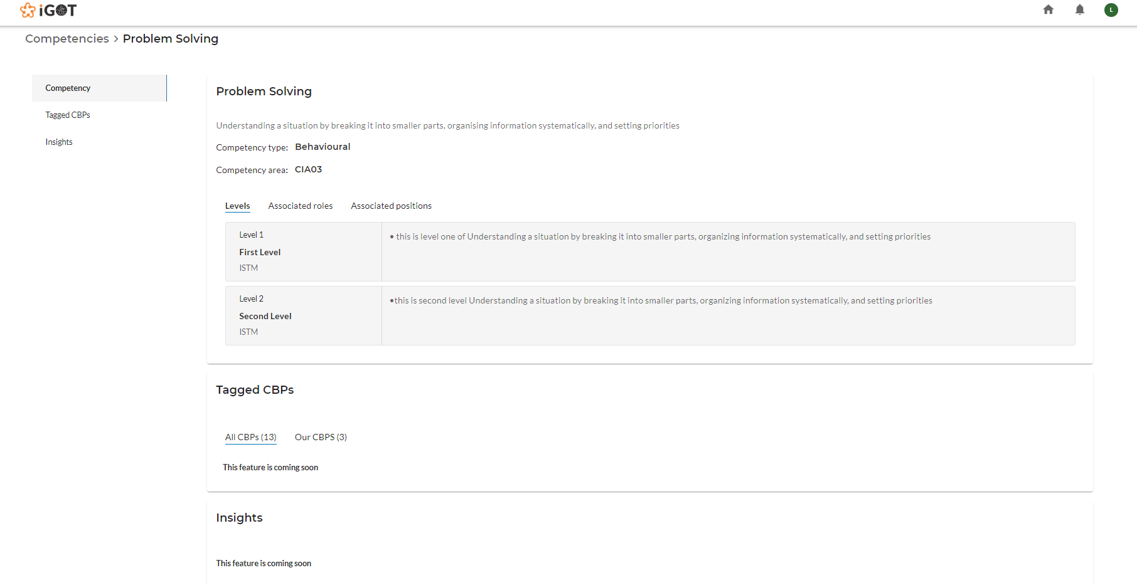

The CBP provider user can request for a new competency by clicking on the “Request new competency” button on the top right. User clicks on that “Request New Competency” button to see the below screen.

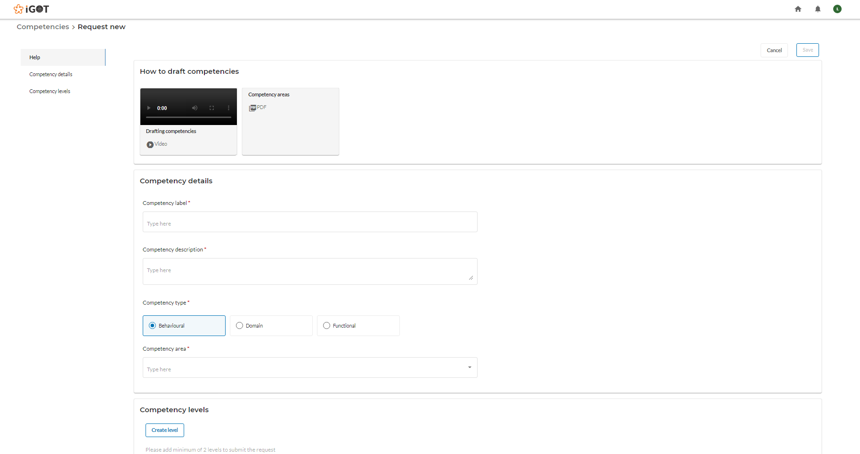

User fills all the details of the competency like Competency label, Competency description, Competency type, Competency area and the Competency levels.

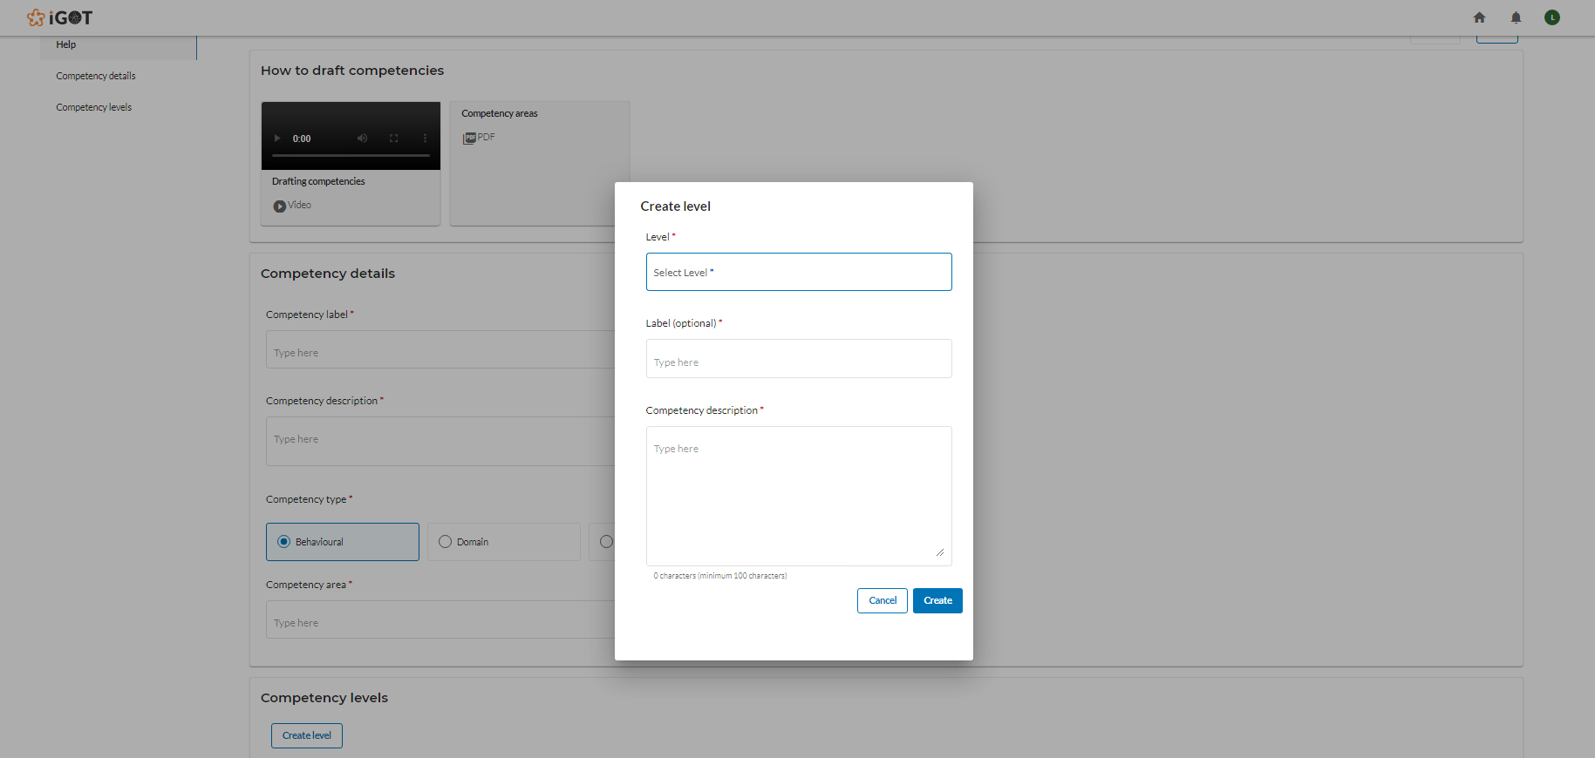

After submission of the competency from the CBP portal, it undergoes a review process in the FRAC tool. Once, the competency is verified, it gets listed in the FRAC dictionary which can then be used for consumption.